PowerFlex 5300
Integrated Motion on the EtherNetIP Network, Config & Startup
& Motion Programming Concepts_JR.pdf
Includes code examples

Most popular Motion Instructions are divided into groups [Motion Programming Concepts_JR.pdf]
- Motion State Instructions
- Motion Process Instructions
- Motion Immediate & Message Instructions
Motion State Instructions

MSO, MSF, MASD, MASR, MDO, MDF, MDS, MAFR

Motion Process Instructions

MAS, MAH, MAJ, MAM, MAG

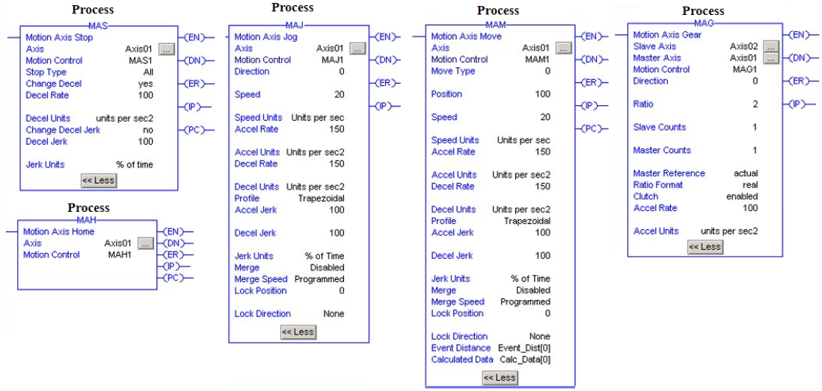
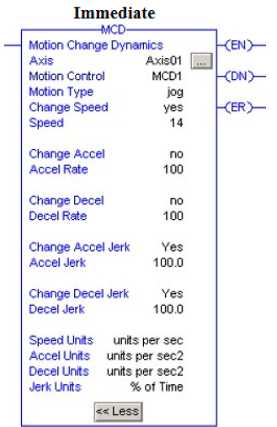
Motion Immediate & Message Instructions
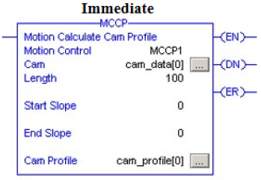
MCD, MRP, MCCP, MCSV
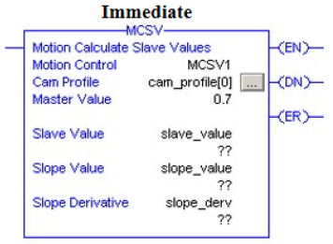
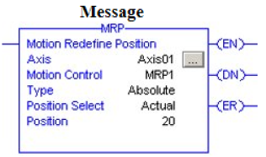

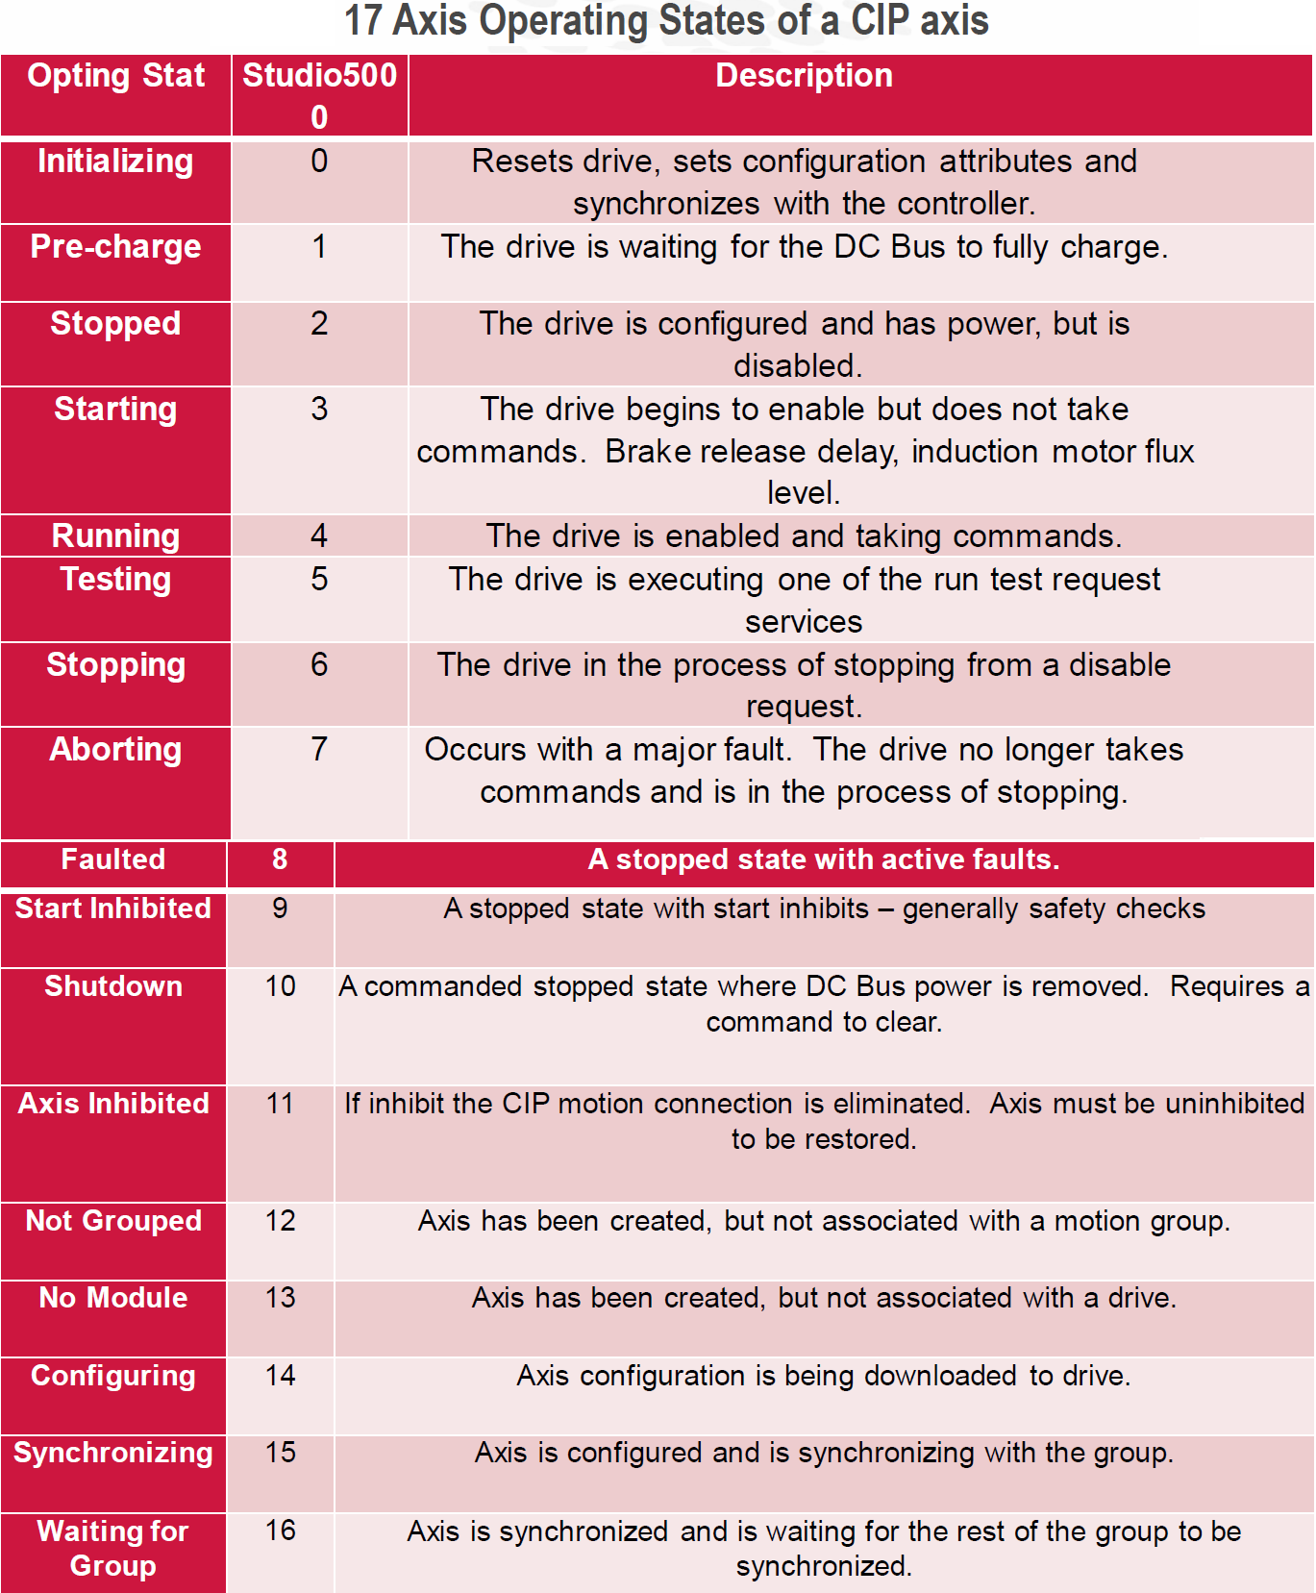

Most Common Motion Programming Mistakes

- Using the same tags for the Motion Control parameter
  - Problem appear when using copy/paste
  - If the instruction or motion is acting weird look at the status bits,
typically they will be flashing on and off if duplicate control word.
  - Use Cross Reference (Ctrl-E) to quickly find duplicate control words
  - Can cause damage to the machine !!
  - Ex.

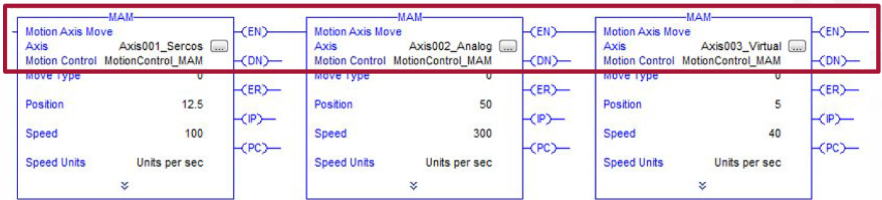

- Never use the .DN bit for “Motion State” instructions or the MAM
- Use a corresponding status bit to verify that the instruction completed successfully and the axis responded
- For MAM, use the PC bit or other logic discussed in a upcoming slide
Ex.
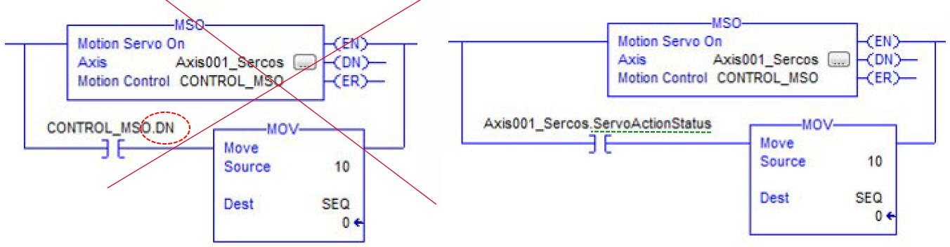
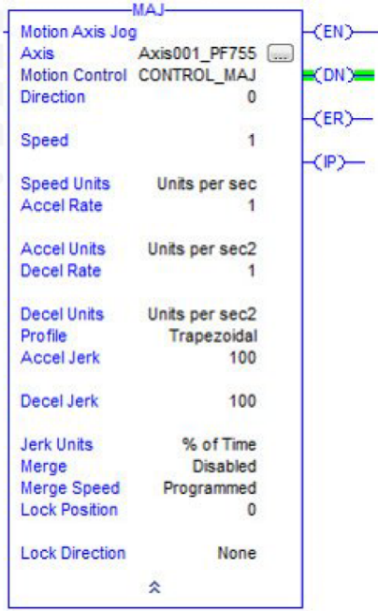
- Never program in “% of Max” units
- Use any other units for Speed, Accel, Decel, and Jerk
- “% of Time” typically used for Jerk
- “Units per Sec3” difficult to visualize

If “% of Max” is used:
- The user must refer back to the Axis Properties for every axis to determine what the true values are for that instruction
- If the Maximum units are changed, all of the values will change possibly causing problems
- Maximum Units can be changed after an Auto-Tune causing a machine to run totally different

- Don’t use a one shot directly in front of a motion instruction
- No point, just a waste of memory and scan time
- Motion Instructions run only once on the rising edge of the input condition

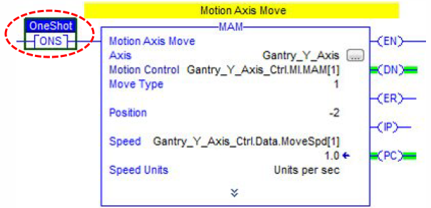

- Be careful of using just the .PC bit of a MAM to determine if an axis is in position
- The .PC bit turns on when the Command Position of the Motion Planner reaches the end point.
- .PC does not take into account the actual position of the axis
- Proper sequence programming can help verify the actual position in conjunction with a couple programming tricks:
  - Use AxisTagName.PositionLockStatus[BOOL] –Turns on when the Position Error is less than or equal to the Position Lock Tolerance value.
  - Write Custom Logic that verifies the actual position of the axis is within a tolerance of where it should be

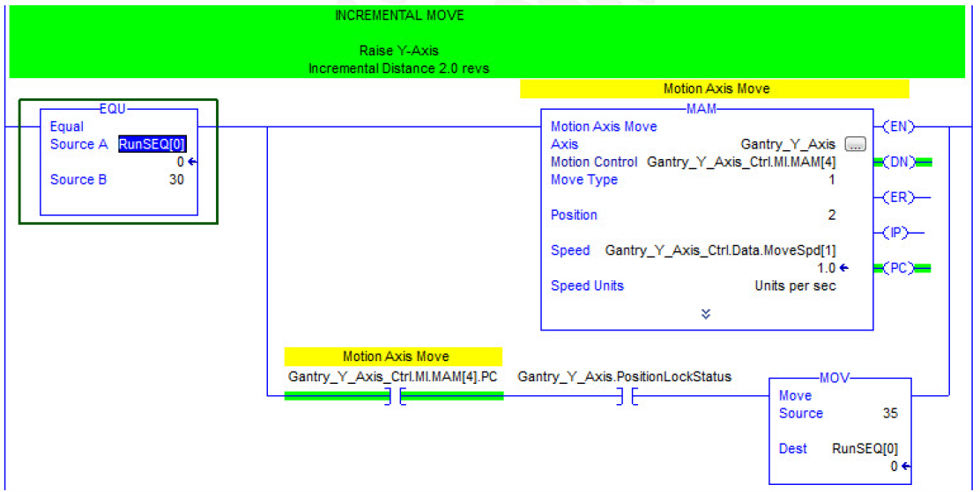

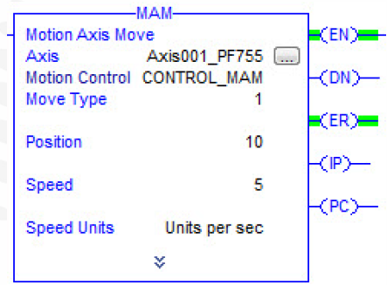
The .ER bit
- If your programming is perfect you should never see the.ER bit
- If your Motion Instructions are properly programmed and have the proper axis status bits conditioning the rung from executing, you should never get a Motion Instruction Error (.ER)

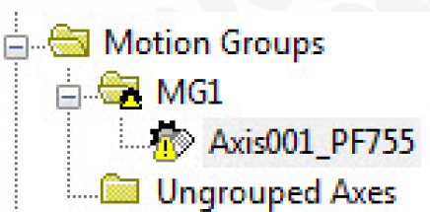
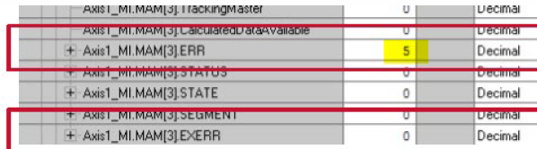

- The .ER bit is NOT the same as an Axis Fault!
- If you have an Axis Fault and try to run anything but a MAFR or MASR you will get an error on your Motion Instruction
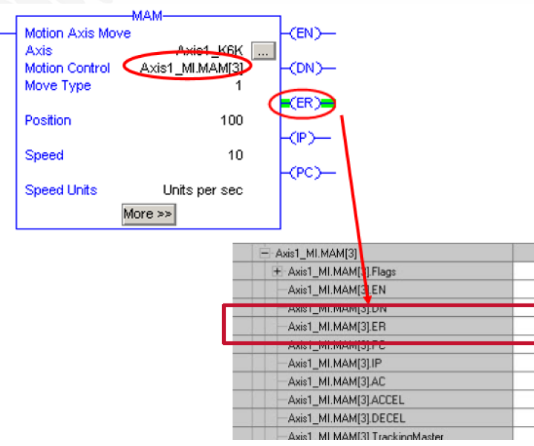
- Motion instructions can cause Axis Faults but when the axis faults, it typically does not cause the .ER bit to turn on.

(The IP bit will turn off and the only thing on will be the .DN bit)

- Do not unlatch the status bits
- Makes it difficult for people to troubleshoot issues when they occur
- In special situations/applications it is allowable to unlatch the enable bit (.EN), that’s it

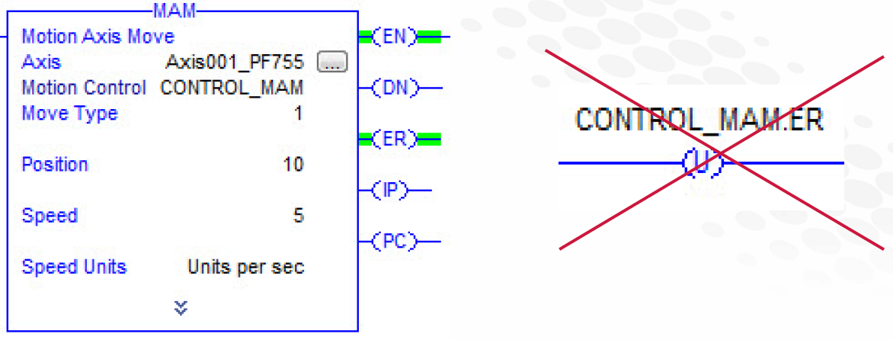
Common Programming Mistakes Summary
- Never use the same Motion Control Tag twice
- Never use the .DN bit for “Motion State” instructions or the MAM
- Never program in “% of Max” unites
- Don`t use a one shot directly in front of a motion instruction
- Be careful of just using the .PC bit of an MAM to determine if an axis is in position
- Using the .ER bit is not a good idea –at least don’t toggle them.
- Do not unlatch the status bits

Motion programming: Tips & Best practices
User Defined Data Types (UDT)
- UDT’s are a very useful programming technique for Motion Control in ControlLogix.
- The UDT’s ability to group related data of dissimilar data types into one structure allows for:
  - Faster program development
  - Better database organization
  - Flexible applications
- If your application contains multiple axis and or multiple motion instructions, it may be beneficial to define a User Defined Data Typefor your Motion Instruction. The benefits include:
  - They are grouped together
  - Helps prevent duplication
  - Easily copied to other projects

UDT’s are a very useful programming technique for Motion Control in ControlLogix.

The UDT’s ability to group related data of dissimilar data types into one structure allows for:
- Faster program development
- Better database organization
- Flexible applications

If your application contains multiple axis and or multiple motion instructions, it may be beneficial to define a User Defined Data Type for your Motion Instruction. The benefits include:
- They are grouped together
- Helps prevent duplication
- Easily copied to other projects

User Defined Data Types (UDT)
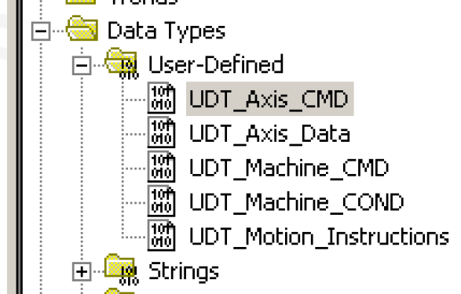
Examples of UDTs in Motion
- Motion Control tags
- Machine Status
- Machine Commands
- Axis Data
- Axis Commands
- Machine Sequences

It is good practice to add the Prefix “UDT_” to the name of your UDT
- Easy to find when browsing for data type during tag creation.
User Defined Data Types (UDT)

Motion Control tags
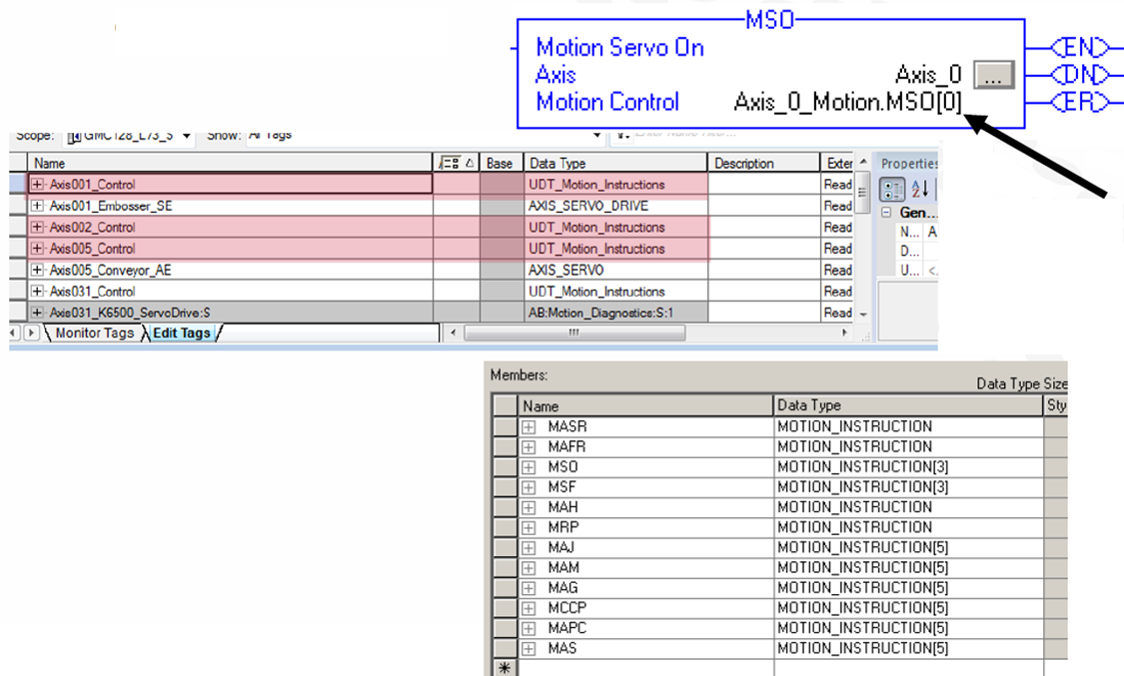
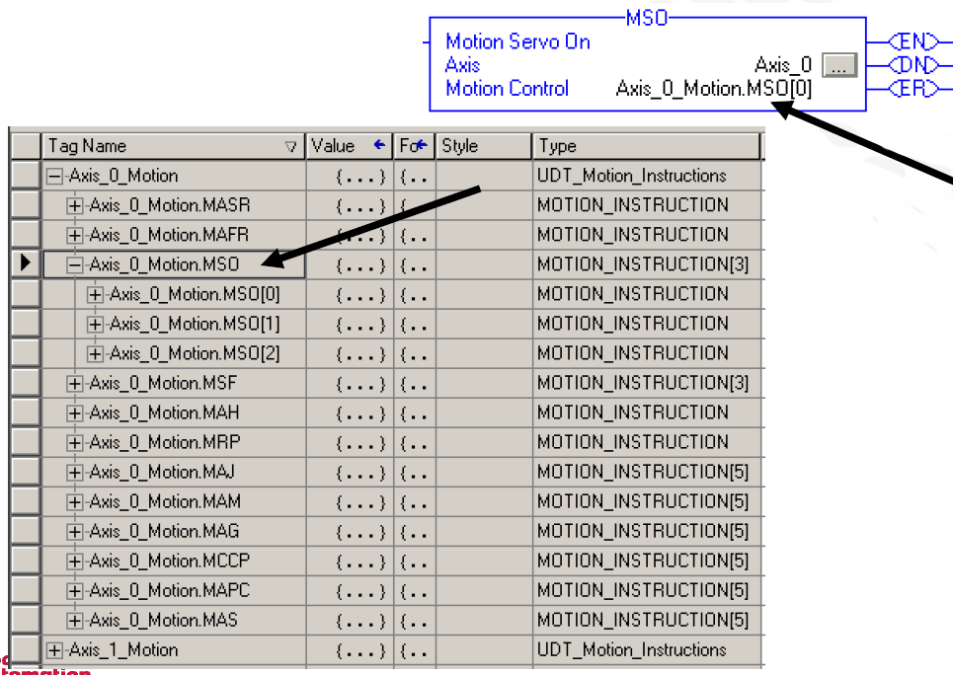
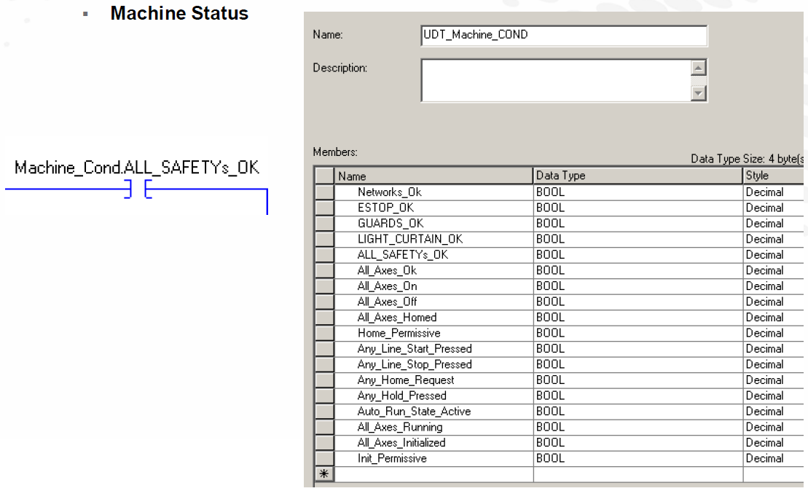

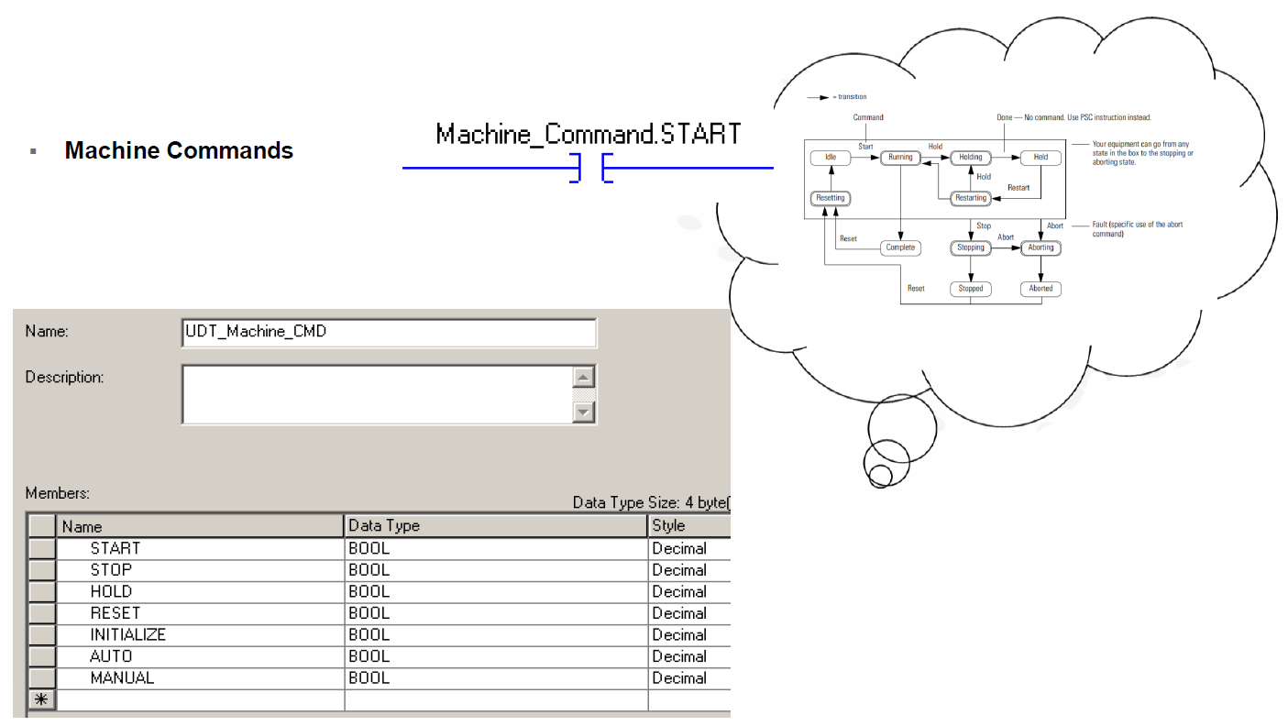

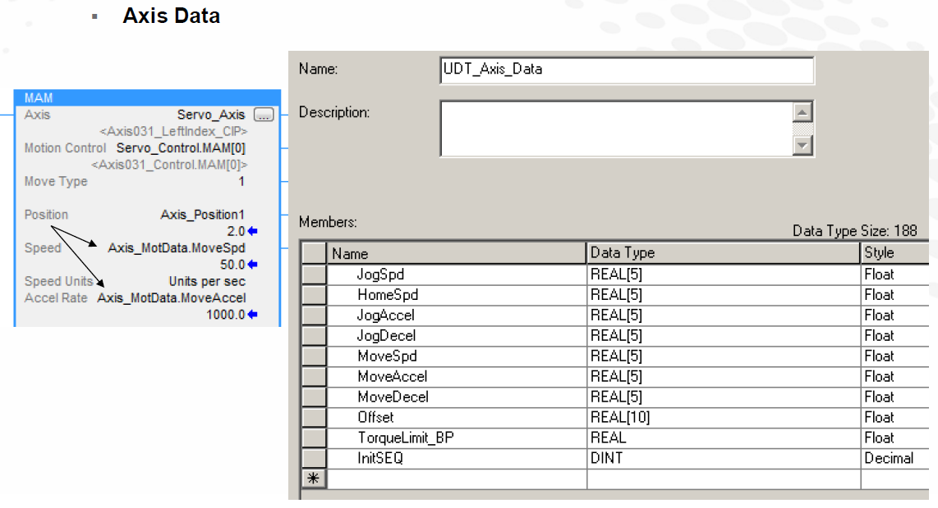

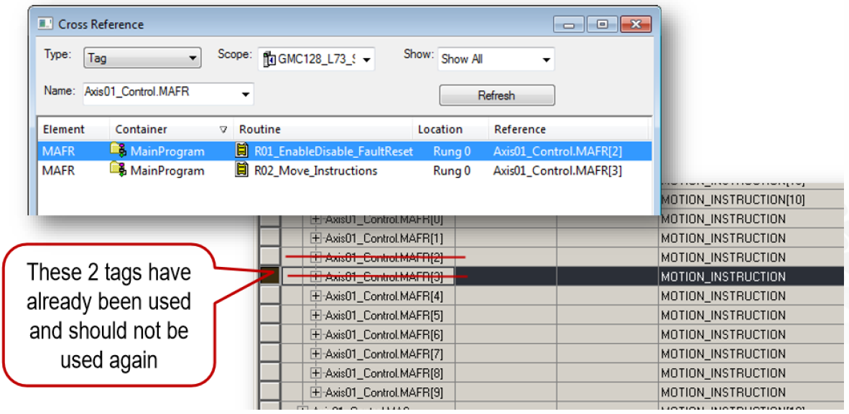

Sequences

What are sequences?
- Sequences are the building blocks of an elaborate machine control system.
- Allows step-by-step control of Logic. (Also called Step Logic)
- Permits simplified trouble-shooting.
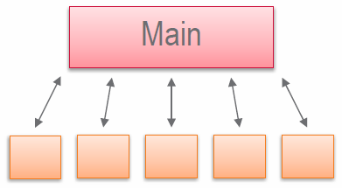
- A machine program typically contains numerous sequences controlled by a Main sequence or Machine State Model.
- Initialization
- Fault Recovery
- Manual/Auto Operation Modes
- Data acquisition

Why are Sequences important in Motion Control?
- Almost everything in Motion control is sequential
Active Switch-Marker homing
Initialize an axis
- Runtime procedures are often sequential
- It gives you the ability to lock-step processes, to accomplish things together
  - Wait for a group of axes or a single axis to finish homing, perhaps out of a dangerous position, then initiate homing on other axes
- It allows you to see where you are in a process and quickly evaluate where it may have failed

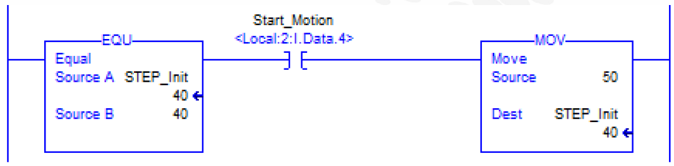

- One widely used technique is to employ the EQU and MOV commands with a Sequence tag.

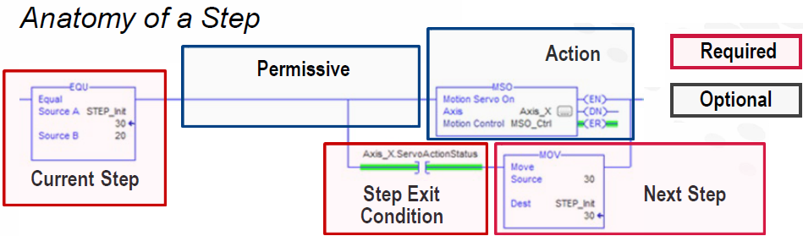
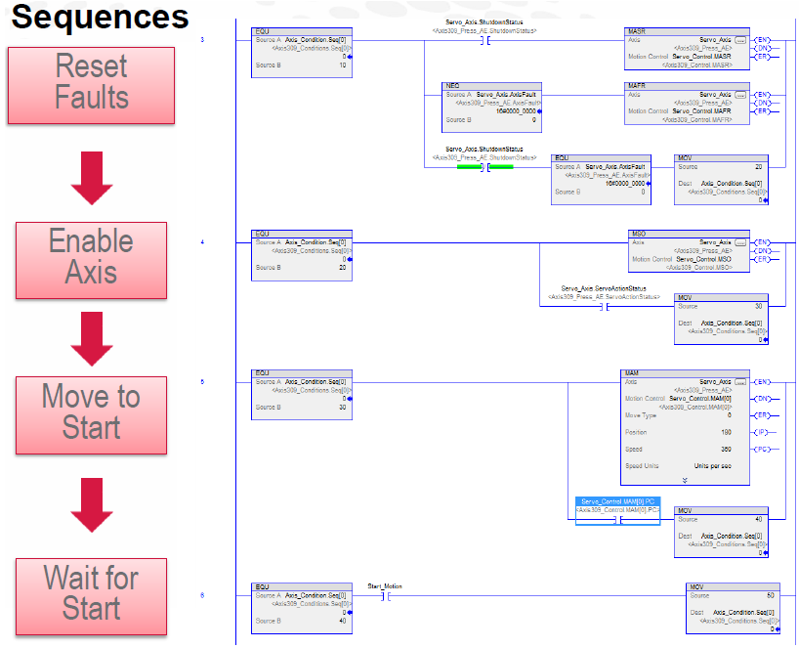
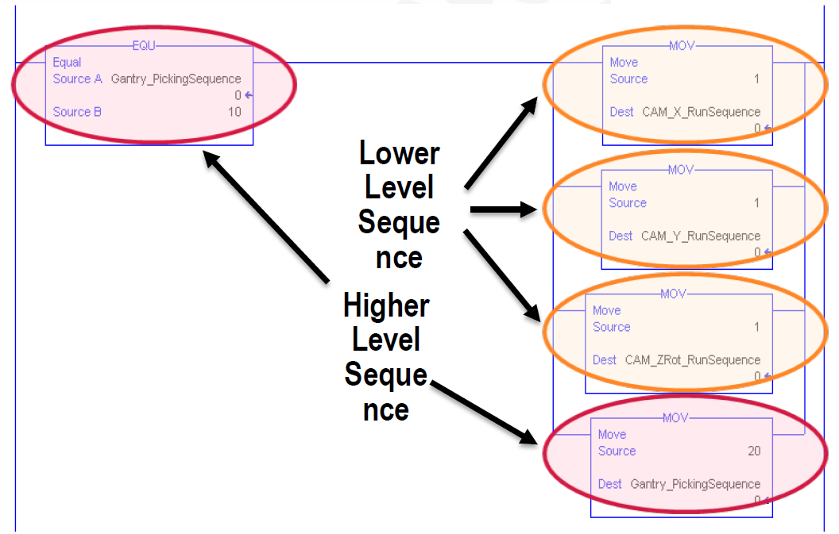

In the example at left, the
GantryPickingState is the main sequence and we use it to control the CAM X, Y, and Z Run Sequences.

GSV & SSV

- Use an interlock mechanism using the bit ConfigUpdateInProcess of the Axis tag
- Even though the ConfigUpdateInProcess bit goes low, it doesn’t mean the parameter was set.
- Reading with a GSV after the bit goes low is the best test to verify that the value was accepted by the controller. Improper values can sometimes generate a Config Fault in an axis.
- If a Config Fault occurs the Attribute Error field will be populated
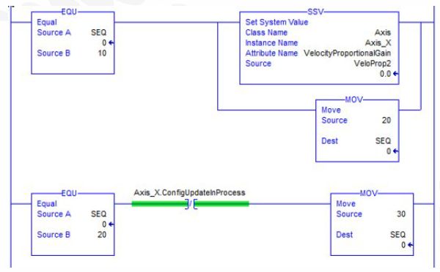
- Do not continuously execute GSVs and SSVs
- GSVs add scan time
- SSVs have been known to cause undesirable motion effects
- Always wait for the ConfigUpdateInProcess bit to go low when using SSV with “Axis” Class Name
- Doublecheck if parameter was accepted by performing GSV
In below example SSV sets Axis090_K350_CIP.ConfigUpdateInProgress low when SSV completed.
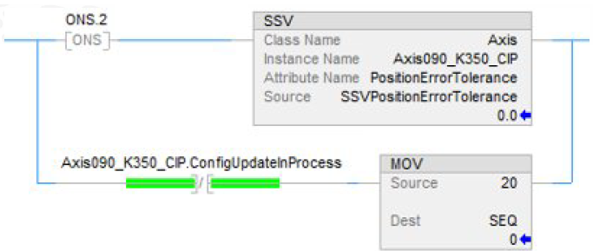
GSV & SSV Example

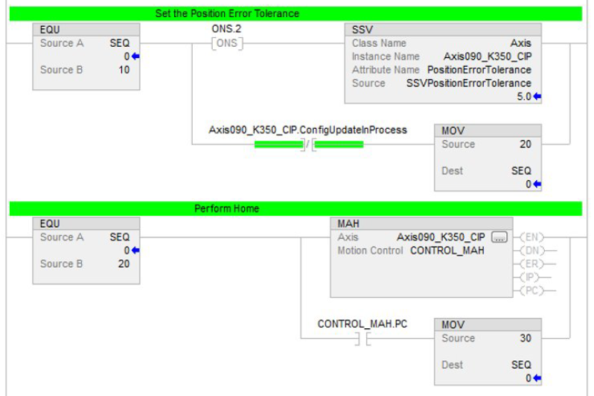

Axis Configuration: most common issues

- Project with periodic tasks (no continuous task)
Appropriate Time Slice configuration
  - Keep an eye at the motion task execution and see what left for the rest of the application and communication, based on the CUP
- Use the Event Tasks sync to CUP mostly when you need fast action (MAR) or fast movement action
- Avoid putting in this Event Task all your motion tasks
- Grand Master Clock configuration
  - Use Ethernet devices that support CIP Motion
  - Use Embedded PLC ETH port for troubleshooting to isolate the problems
- Re-create instruction (remove it from code, add & configure again) if you are experiencing some wierd issues. Wrong calculations –rare but possible.
- Avoid changing Kinetix Firmware with working code (better recreate Axis from scratch)
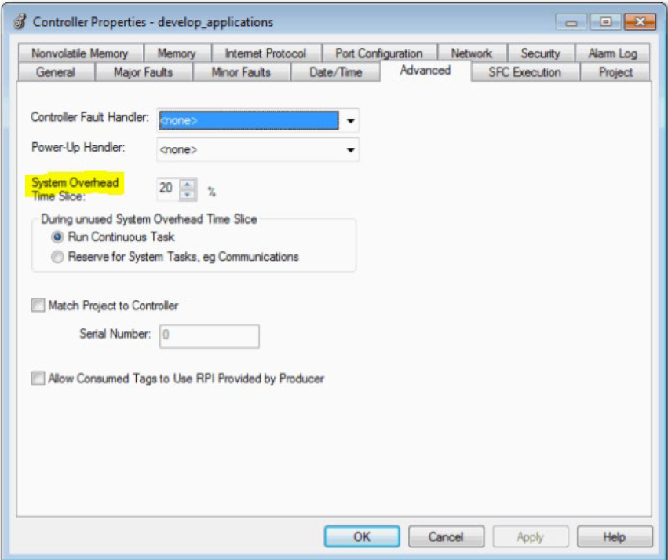

References:
- Using Wireshark to analyze CIP Motion Ethernet traffic: KB 1063344
- Integrated Motion on the EtherNet/IP Network: Configuration & Startup
- Integrated Architecture and CIP Sync Configuration
- Phase Manager Software

Ultra3000 Digital Servo Drives to Kinetix 5300 Servo Drives – Migration Guide

Motion Analyzer for Kinetix 5300: https://motionanalyzer.rockwellautomation.com/
Motion Analyzer – is a comprehensive motion-application sizing tool that is used for analysis, optimization, selection, and validation of your Kinetix motion control system.

Electrical Noise Reduction – See the System Design for Control of Electrical Noise Reference Manual, publication GMC-RM001 or Servo Drive Installation Best Practice Application Technique, publication MOTION-AT004, for information on the concept of high-frequency (HF) bonding, the ground plane principle, and electrical noise reduction.

For more information on Ethernet design considerations, see these publications:
• Scalability - The Best Approach to Change, publication IA-WP002
• EtherNet/IP Design, Commissioning, and Troubleshooting Quick Reference, pub IASIMP-QR023
• Integrated Motion on EtherNet/IP Configuration Drawing with Notes, pub IASIMP-QR019
• Integrated Motion on Sercos & EtherNet/IP Network – Analysis & Comparison, pub MOTION-AT006
• See the Knowledgebase Technote: Qualifying Logic for MSO

Sizing for protective devices, such as fuses and circuit breakers, can be different between Ultra3000 servo drives and Kinetix 5300 servo drives. Verify that you have chosen the correct sizes when selecting and installing a Kinetix 5300 servo drive. For more information, see Circuit Breaker and Fuse Considerations.

The Kinetix 5300 includes four configurable digital inputs available for the machine interface on the digital input connector and six configurable functions to choose from in the Studio 5000 Logix Designer® application (version 33.00 or later). Configurable functions are Enable, Home, Registration 1, Registration 2, Positive Overtravel, and Negative Overtravel. Digital inputs require a 24V DC @ 15 mA supply. These are sinking inputs that require a sourcing device. A common and cable shield connection is provided on the connector for digital inputs.

Motor Brake – The brake option is a spring-set holding brake that releases when voltage is applied to the brake coil in the motor.

The Kinetix 5300 servo drive has a dedicated motor brake circuit which can be wired directly to a motor brake rated 2.25A and below, or it can be used to drive an interposing relay. Motor power and brake connections are made at the motor power and motor brake power connectors on the front of the drive. The solid-state brake circuit provides current-overload protection and brake overvoltage protection.

When replacing a Ultra3000 with a Kinetix 5300, do not wire a customer supplied power supply to the motor brake circuit of the Kinetix 5300 drive. Instead, either wire the motor brake circuit directly to the motor brake, or use the 24V supplied by the Kinetix 5300 motor brake connector to drive an interposing relay.

For the Safe Torque Off connector pinout, installation, and wiring information, see the related chapter in the Kinetix 5300 Servo Drives User Manual, publication 2198-UM005.

The AC line filters required to meet CE compliance for Kinetix 5300 are different than those needed by the Ultra3000. Kinetix 5300 servo drive accessories include AC line filters and Bulletin 2097 and 2198 external shunt resistors. See Accessories on page 41.
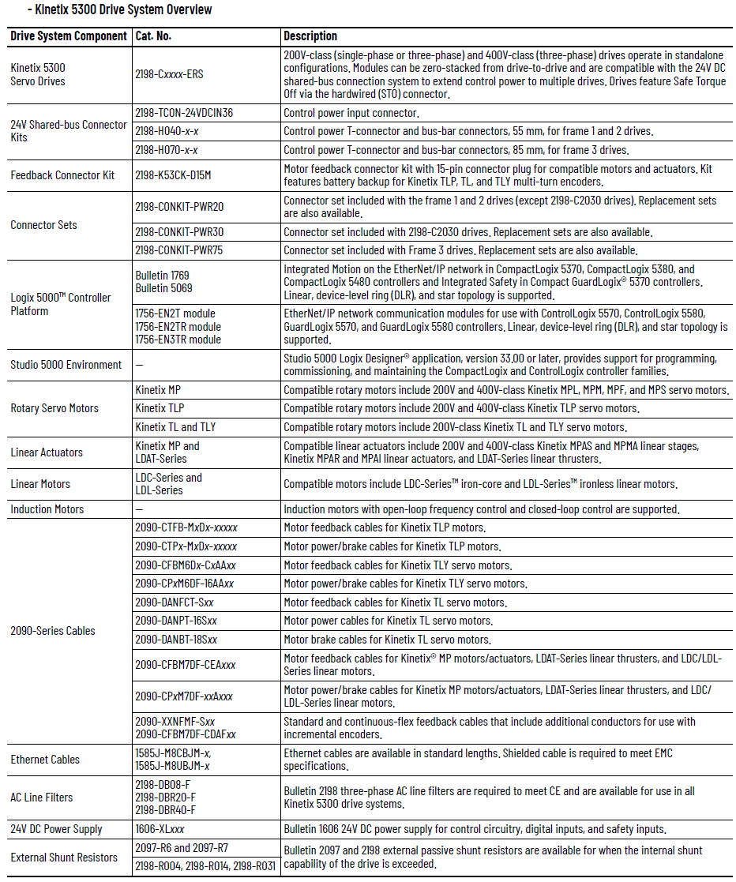

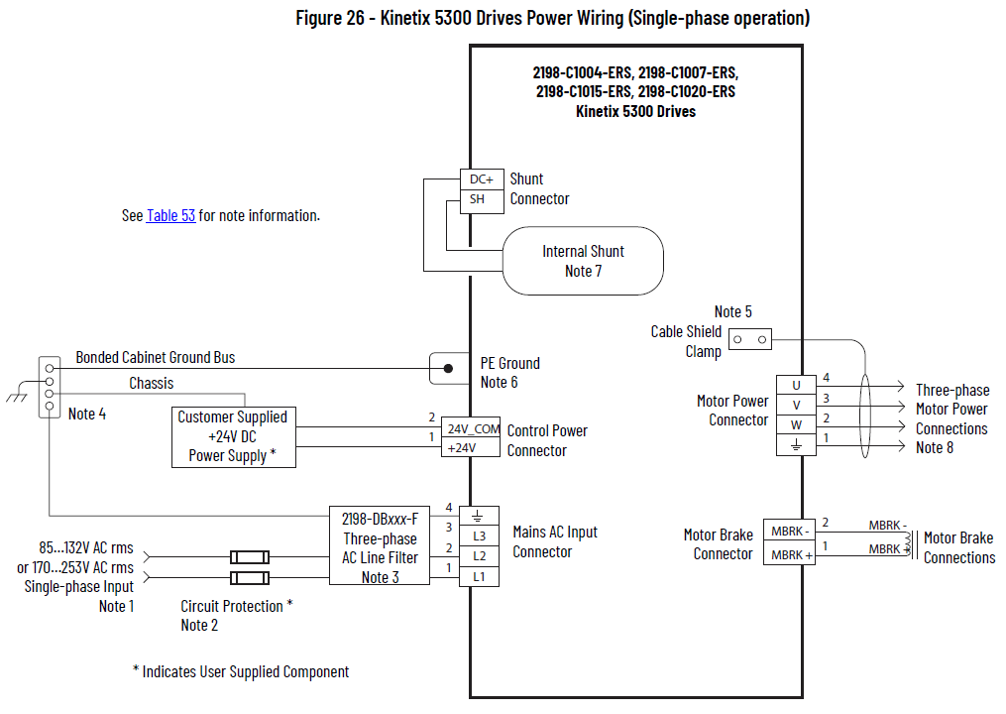

Kinetix 5300 Servo Drive Linear Topology

In this example, all devices are connected in linear topology. The Kinetix 5300 drives include dual-port connectivity, however, if any device becomes disconnected, all devices downstream of that device lose communication. Devices without dual ports must include the 1783-ETAP module or be connected at the end of the line.

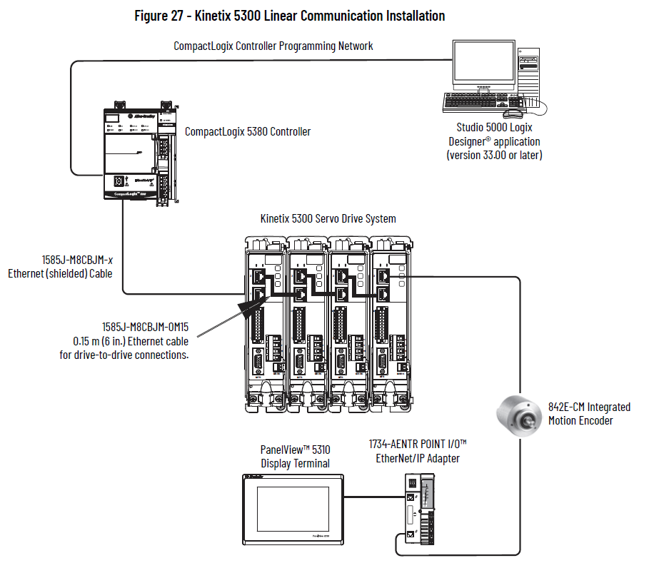

Ring Topology

In this example, the devices are connected by using ring topology. If only one device in the ring is disconnected, the rest of the devices continue to communicate. For ring topology to work correctly, a Device Level Ring (DLR) supervisor is required (for example, the CompactLogix controller). DLR is an ODVA standard. For more information, See the EtherNet/IP Embedded Switch Technology Application Guide, publication ENET-AP005. Devices without dual ports require a 1783-ETAP module to complete the network ring.

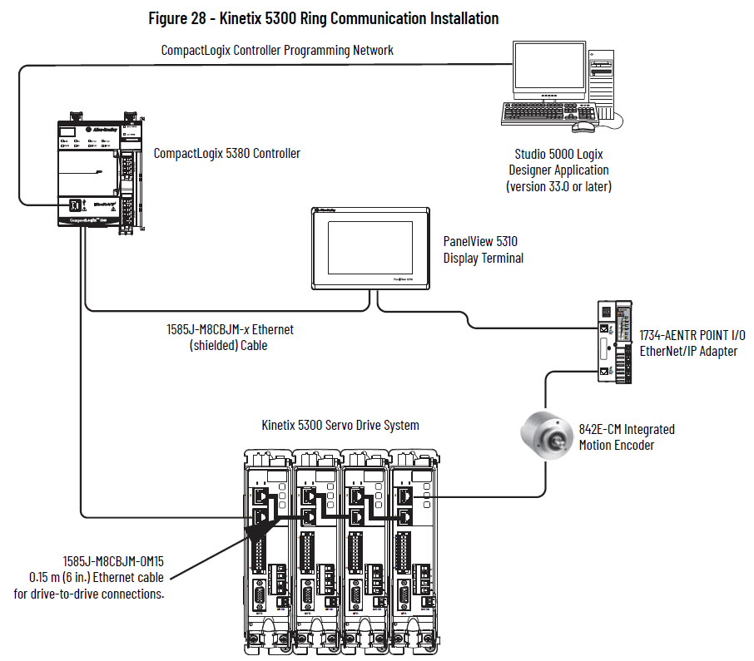

Star Topology

In this example, the devices are connected by using star topology. Each device is connected directly to the switch. Kinetix 5300 drives have dual ports, but in star topology all drives are connected to the switch. Kinetix 5300 and other devices operate independently. The loss of one device does not impact the operation of other devices.

You can use the 842E-CM integrated motion encoder for applications requiring an external encoder for gearing or camming to the Kinetix 5300 drive. By providing auxiliary feedback directly through the EtherNet/IP network, the 842E-CM encoder helps eliminate the need for point-to-point wiring while letting customers use the encoder in a variety of network topologies. For more information, see the 842E-CM Integrated Motion on EtherNet/IP Product Profile, publication 842ECM-PP001.

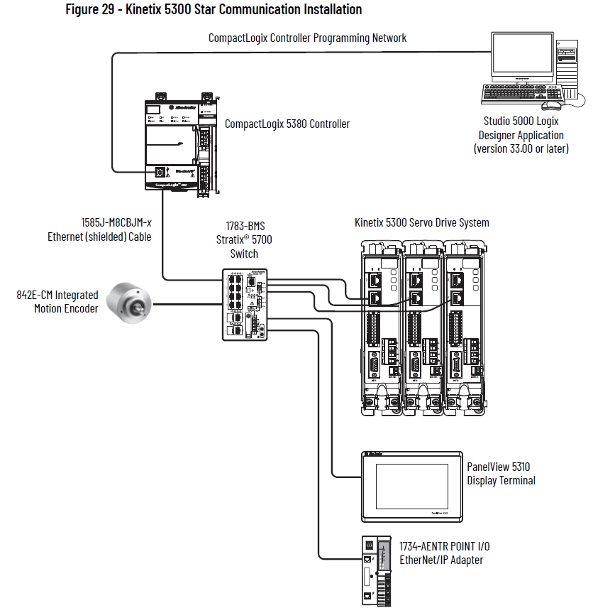

Integrated Motion on the EtherNet/IP Network: Configuration and Startup

The Kinetix 5300 servo drive is an entry-level servo drive integrated on EtherNet/IP.
KEYING
Keep these considerations in mind when creating your motion project.

- For a Motion and Safety application, you must add a GuardLogix® integrated safety controller.
- For all communication modules, use the firmware revision that matches the firmware revision of your controller. See the release notes for the firmware version of your controller.
- The electronic keying feature automatically compares the expected module, as shown in the configuration tree, to the physical module before communication begins.

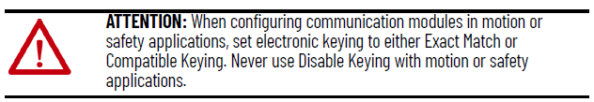

For more information about electronic keying, see the Electronic Keying in Logix 5000™ Control Systems Application Technique, publication LOGIX-AT001.
- Time synchronization supports highly distributed applications that require time stamping, sequence of events recording, distributed motion control, and increased control coordination. All controllers and communication modules must have time synchronization enabled for applications that use Integrated Motion on the EtherNet/IP network.

See the Integrated Architecture® and CIP Sync Configuration Application Technique, publication IA-AT003, for detailed information on time synchronization.

ATTENTION: The electronic keying feature automatically compares the expected module, as shown in the configuration tree, to the physical module before communication begins. When you are using devices in an integrated motion application, set the electronic keying to either Exact Match or Compatible Keying. Never use Disable Keying with motion or safety modules. For more information about electronic keying, see the Electronic Keying in Logix 5000™ Control Systems Application Technique, publication LOGIXAT001.

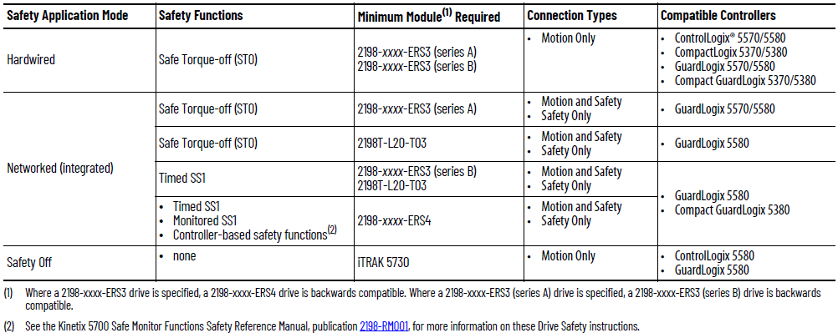
Configure Power Settings

Consider the following when choosing the appropriate settings for your application.
- The Logix Designer application enforces shared-bus configuration rules for Kinetix drives, except for shared AC configurations.

ATTENTION: To avoid damage to equipment all modules that are physically connected to the same shared-bus connection system must be part of the same bus-sharing Group in the Studio 5000 Logix Designer application.

- Kinetix 5500 drives with single-phase operation is limited to 2198-H003-ERSx, 2198-H008-ERSx, and 2198-H015-ERSx.
- Single-phase operation is possible only when Module Properties > Power tab > Bus Configuration is configured as Standalone and Voltage is configured as 200…240V AC.

ATTENTION: To avoid damage to equipment, make sure the AC input voltage that is configured in the Logix Designer application matches the actual hardware being configured.

Example from Kinetix 5700:

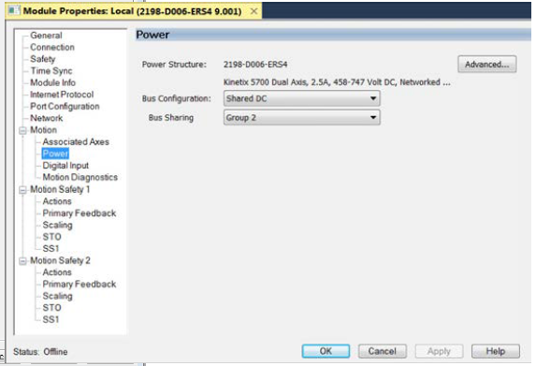

Configure Digital Inputs

The following restrictions apply to settings made on this page:

- All digital input parameters, except Unassigned, must be unique.
- At least one Digital Input must be set to Regeneration OK when a module is set to the Shared DC - Non-CIP Converter bus sharing configuration in the Power tab.
- When you use the 2198-R014, 2198-R031, or 2198-R127 external passive shunt resistor with a DC-bus power supply, the Shunt Thermal Switch Digital Input must be configured.

Configure the digital inputs to monitor the status of drive functions appropriate to your application.

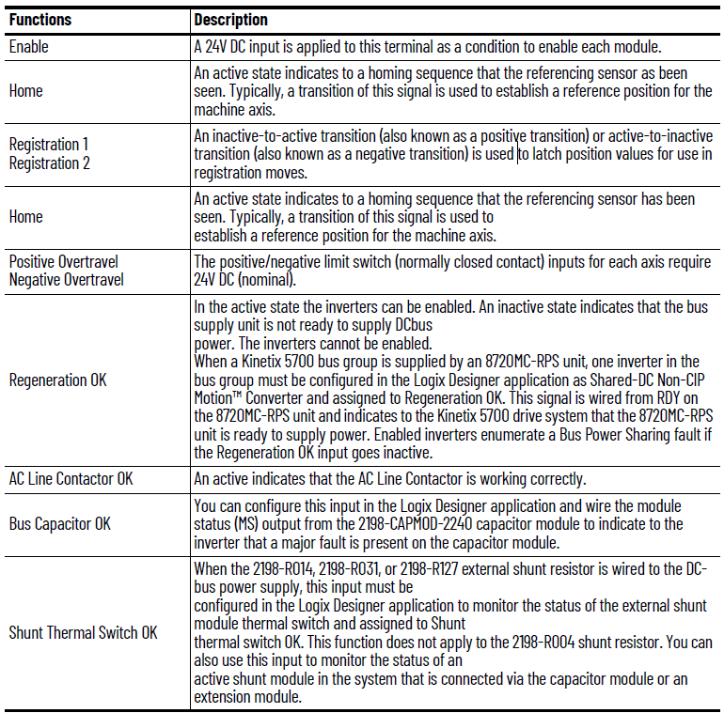

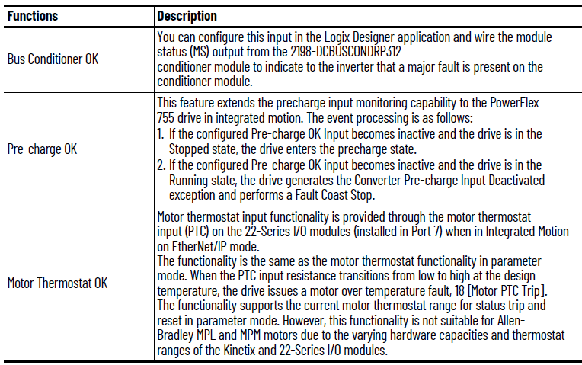

Configure Digital Outputs

The Digital Outputs tab is only available for PowerFlex 755 drives with a digital I/O option card installed as a peripheral device. The appearance of the tab varies depending on the device configuration.

Configure Safety Settings

If your system includes a drive that supports integrated safety, note the safety network number (SNN) on the Module Properties General page, which populates automatically when you add a drive that supports integrated safety to the project.

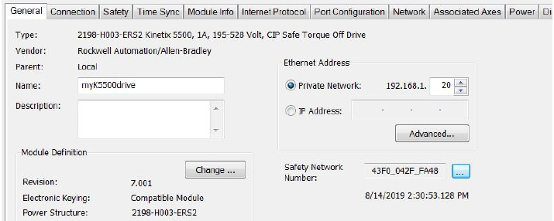
Safety network numbers for PowerFlex drives that include 20-750-S3 or 20-750-S4 option modules are unique. SNNs for other drives match the SNN of the safety controller in the project.

If any differences are detected, the connection between the GuardLogix controller and drive is lost, and the yellow yield icon appears in the controller project tree after you download the program.

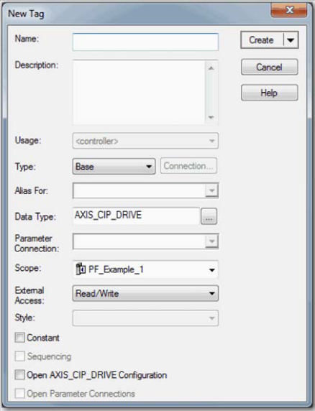
Configure Axis Properties
(Abbreviated treatment)

Create an Associated Axis

1. To open the Module Properties dialog box, double-click the drive in the Controller Organizer.
2. Click the Associated Axes tab.
3. Click New Axis.
4. On the New Tag dialog box, type a name for the axis.
5. Make any adjustments for your application.
6. Click Create.
7. Configure additional axes, if applicable.

Specify Feedback Assignments

The type of feedback you can assign differs based on the type of drive.

IMPORTANT The Logix Designer application prevents the creation of feedback port assignments with incompatible feedback types. For example, you cannot assign the same port for multiple devices. The same port cannot be used for Motor Feedback Device, Load Feedback Device, and Master Feedback Device.

Create a Motion Group

All axes must be added to the Motion Group in your project. If you do not group the axes, they remain ungrouped and unavailable for use. You can only have one Motion Group per Logix controller.

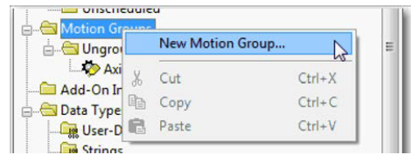
To create a motion group, follow these instructions.
1. In the Controller Organizer, right-click Motion Groups and choose New Motion Group.
2. Type a name for the motion group.
3. Make any adjustments for your application.
4. Click Create.
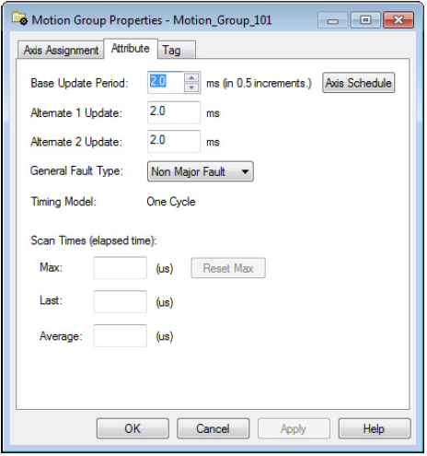
Set the Base Update Period

The Base Update Period is basically the RPI rate for Ethernet communication between the controller and the motion module, a Unicast connection. There are two alternate update periods that you can configure when using the Axis Scheduling function. See Axis Scheduling Configuration on page 68 for details.

- The Base Update Period determines how often the Motion Task runs.
- When the Motion Task runs, it interrupts most other tasks regardless of their priority.
- The Motion Task is the part of the controller that takes care of position and velocity information for the axes.

The Base Update Period is a trade-off between updating positions of your axes and scanning your code. In general, you do not want the Motion Task to take more than 50% of the overall Logix controller time on average. The more axes that you add to the Motion Group, the more time it takes to run the Motion Task.

Configure an Axis and Control Mode Can be found on page 43.

Compare the Axis Configuration Types for the Kinetix Drives

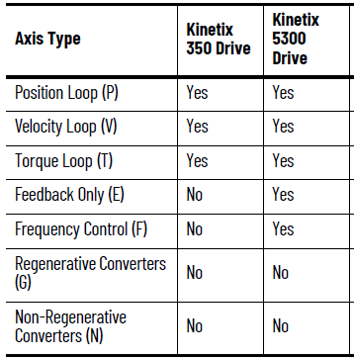

This table provides the gains that are established based on the application type.

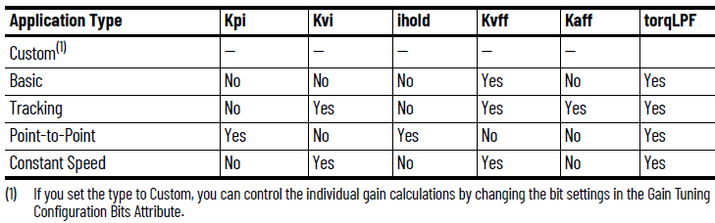
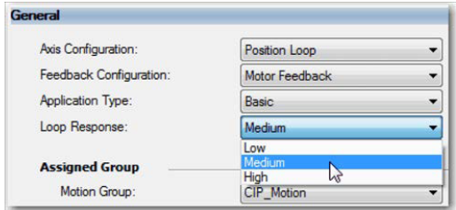
Include in the table that:
- Kpi = Position Integrator Bandwidth
- Kvi = Velocity Integrator Bandwidth
- iHold = Integrator Hold
- Kvff = Velocity Feedforward
- Kaff = Acceleration Feedforward
- torqLPF = Torque Low Pass Filter
Figure 1 Choose a loop response, if applicable.

Loop Response settings also impact the calculations that are made and can minimize the need for you to perform an Autotune or a Manual Tune. The loop response impacts the spacing between the position and velocity loops and the proportional and integral gains. This response impacts how aggressively a given profile is tracked.

For information about other application type and loop response settings and attribute calculations, see the specific attribute descriptions in the Integrated Motion on the EtherNet/IP Reference Manual, publication MOTION-RM003.

Specify the Motor Data Source

On the Motor dialog box you specify what motor you want to use and where the data is coming from:
- Specify a motor with the Data Source = Catalog Number.(1)
- Specify a motor with the Data Source = Nameplate Datasheet.
- Select a motor with the Data Source = Motor NV (Kinetix Drives) or Drive NV (PowerFlex 755 Drives)(1)

To choose a motor from the Motion Database, follow these steps.
1. If the Axis Properties dialog box is not open, double-click the axis.
2. Go to the Motor dialog box of Axis Properties.
3. From the Data Source pull-down menu, choose Catalog Number.
4. Click Change Catalog.
5. Select a motor.
6. The Motor dialog box is now populated with all information that is related to the motor you selected from the Motion Database.
7. Click Apply.

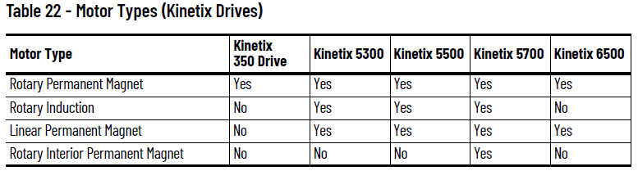
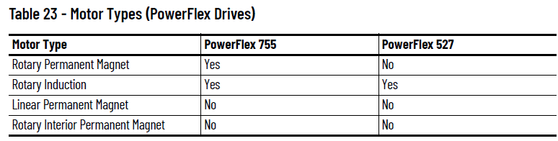

The motor information fields are initialized to defaults.

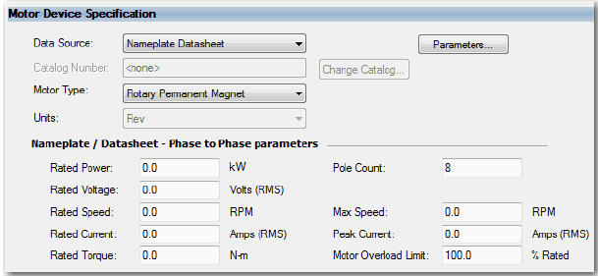

Enter the parameter information from the motor Nameplate Datasheet and click Apply.

For some drives, you can use the Motor Analyzer tool to identify the model for motors that have the data source set to Nameplate Datasheet.

The Motor Analyzer provides the following three tests:
- Dynamic Motor
- Static Motor
- Calculate Model

The tests analyze motor parameters for rotary and linear induction motors and permanent magnet motors. The parameters that appear on the tests are dependent on the motor type you choose.

Configure Commutation

If a permanent magnet motor is selected from the Motion Database, the Commutation Alignment is set to Controller Offset. However, if a permanent magnet motor is specified from Nameplate Datasheet, you must specify the Commutation Alignment method. The default is set to Not Aligned.

In most cases, the Commutation Alignment is set to Controller Offset and the Commutation test is run during commissioning to determine the Commutation Offset and Polarity. See the Integrated Motion Reference Manual, publication MOTION-RM003, for more information on axis attributes.

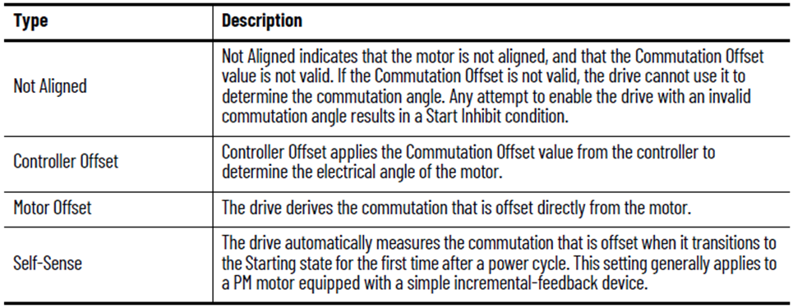

Configure Exceptions

Drives with Motion Only connections let you define the action performed by the drive as a result of an exception condition. Exceptions are conditions that can occur during motion axis operation that could generate faults or alarms.

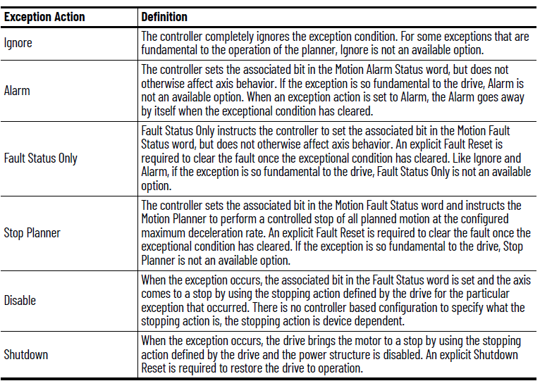
Configure Actions

Configure standard actions to determine how the axis responds to certain faults. The options available for each of the actions depend on the axis configuration and information from the drive's profile. See Table 28.

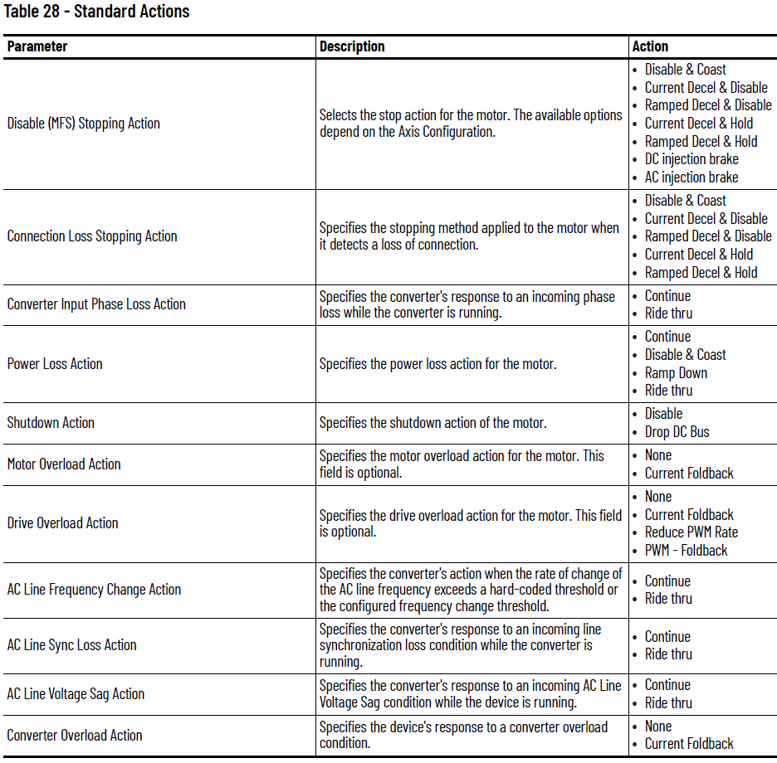

Axis Scheduling

Axis Scheduling provides a way for you to configure drives to run at different update rates. Axis Scheduling can improve the performance of your controllers. You can use Axis Scheduling with integrated motion drives and virtual axes. By using Axis Scheduling, you can optimize your controller, network, and drive performance. For smaller controller applications (CompactLogix™), you can expect to see a significant improvement in system performance.

Many applications have motion drives with different performance requirements. At the simplest level, motion drives can be assigned into a ‘fast’ and ‘slow’ update rate groupings.
- The ‘fast’ group typically includes high-speed coordinated process positioning drives with aggressive PCAM or interpolation profiles and auxiliary functions like registration position/velocity phase correction.
- The ‘slow’ group typically includes non-coordinated motion drives used for automatic machine reconfiguration, non-coordinated point-to-point motion process drives, or coordinated drives with less aggressive PCAM or gearing functions.

Axis Scheduling can improve ControlLogix and CompactLogix EtherNet/IP Integrated Architecture Motion system performance by reducing average Logix controller and EtherNet/IP network utilization. Axis Scheduling supports three separate controller/network motion drive update rates per controller, one rate for high-performance drives, and two additional rates for lower performance drives.

Timing Model

The general timing model for the integrated motion on the EtherNet/IP network I/O connection data exchange is described in this section. The Timing Model field on the Attribute tab of the Motion Group Properties dialog box is shown as One Cycle or Two Cycle. See Figure 9 for an example.

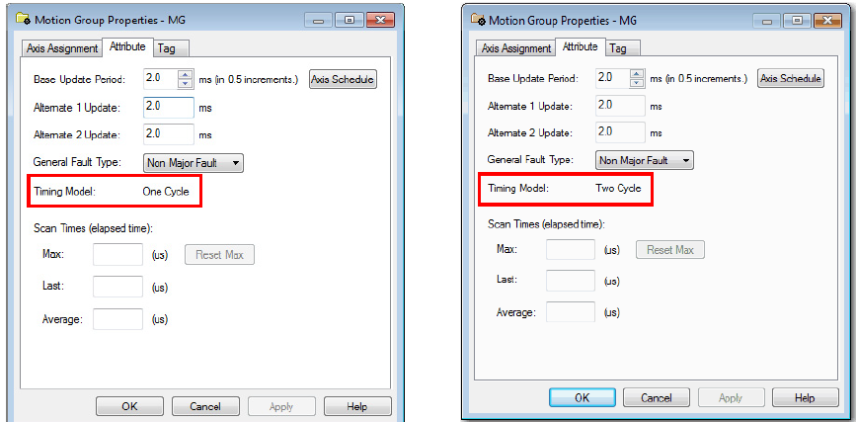

One Cycle Timing

The Controller Update Period paces data exchange between the device and the controller with one Device-to-Controller data packet that is sent for every Controller-to-Device data packet received. The Controller-to-Device Connection packets are sent periodically according to the configured Controller Update Period.

Two Cycle Timing

The Two Cycle Timing Model that is shown in Figure 11 begins with the device transmitting the D-to-C connection packet to the controller at the beginning of the update cycle. In this case, the Controller Task does not start until half way through the update cycle. This start point allows more time for the D-to-C connection packet to reach the controller before the Motion Planner task runs. Unlike the One Cycle Timing Model, the C-to-D connection packet is not transmitted back to the device until the next time the Motion Planner task runs. This delay again allows more time for the C-to-D connection packet to reach the device.

Axis Scheduling Configuration

In the Studio 5000 Logix Designer application, you use the Axis Schedule Panel, accessible from the Attribute tab of the Motion Group Properties dialog box, to configure the update periods. The Axis Schedule Panel provides a Base Update Period and two alternatives. Information such as Estimated Utilization and Actual Utilization appear on this panel.

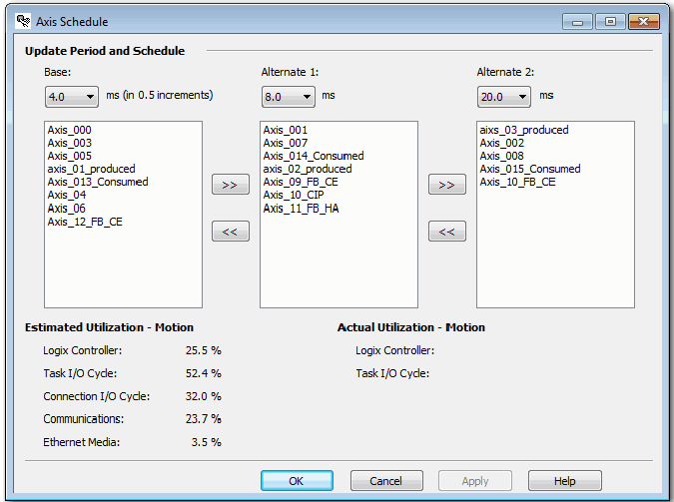
Once an alternate rate is set on the Axis Schedule Panel, the Base Update Period for the group on the Attribute tab becomes disabled. You can still set the base update rate on the Axis Schedule Panel. A warning appears and the value is set to either 0.5 or 32 if you enter a value outside of the acceptable range.

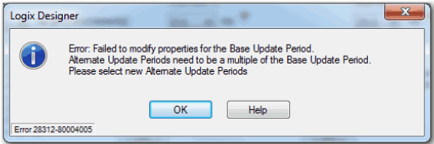

If the Base Update Period is too small, the controller does not have time to execute non-motion related Ladder Logic.
As a result, the configuration sets the lower limit on the Base Update Period that is based on the number of axes in the group. You can use Integrated Architecture Builder (IAB) to determine the performance information that is based on your system configuration.

Too many axes per base rate can indicate one of the following:
- There is not enough time for the motion task to execute, which results in a motion task overlap error.
- There are high-application program scan times, which affect all logic: program logic that supports motion applications and general program logic.

If the base update rate is changed to a value that invalidates the alternate update rates, a warning tool tip appears.

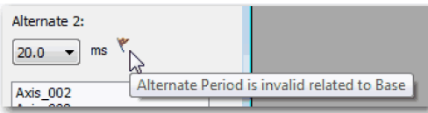

The following values are updated in real time as you change your configuration. You can see how the utilization metrics are responding to your configuration changes and you can modify your configuration.

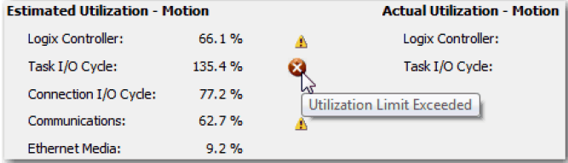
Configuration Examples for a Kinetix Drive

Example 4: Kinetix 5500 Drive, Velocity Loop with Motor Feedback

In this example, you are configuring a Kinetix 5500 servo drive, catalog number 2098-H025-ERS, with motor feedback by using a Rotary Permanent Magnet motor, catalog number VPL-A1001M-P.

You must connect the Motor Feedback cable to the Motor Feedback port of the Kinetix 5500 drive and then configure the feedback port.

1. Once you have added the drive to your project and created an AXIS_CIP_DRIVE, open the Axis Properties.

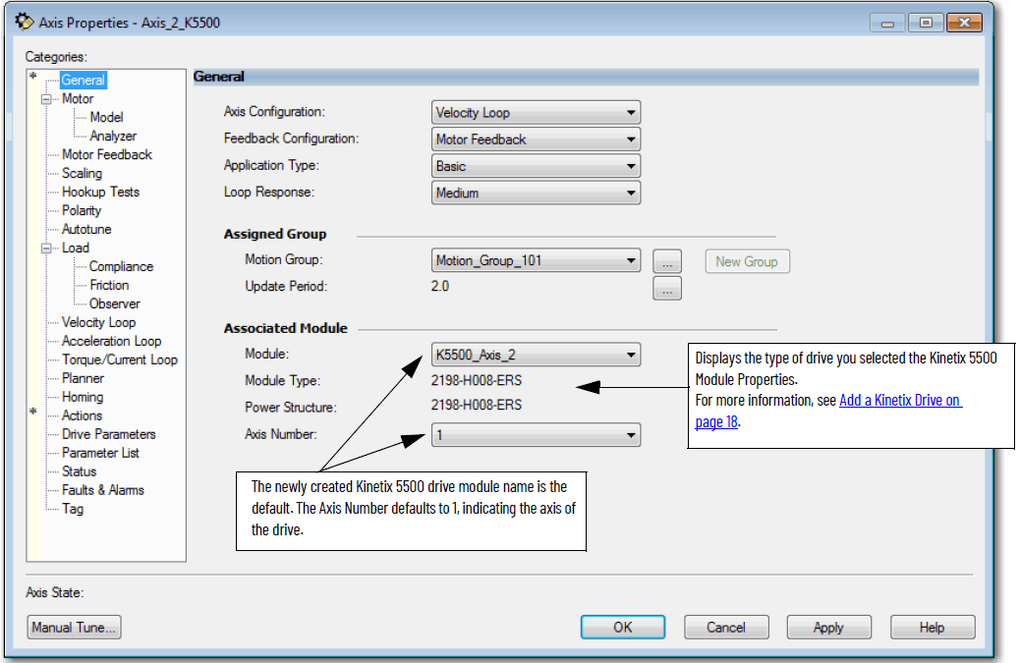

After you have configured the axis and you change the Axis Configuration type or the Axis Number, some of the configuration information is set to default values. This change can cause some previously entered data to be reset back to its default setting.

After you select Velocity Loop with Motor Feedback, the Motor and Motor Feedback dialog boxes become available.

2. Click the Motor dialog box.
3. Choose Catalog Number as the Motor Data Source.
4. Click Change Catalog and choose your motor, for example, catalog number VPL-B0631T-C.

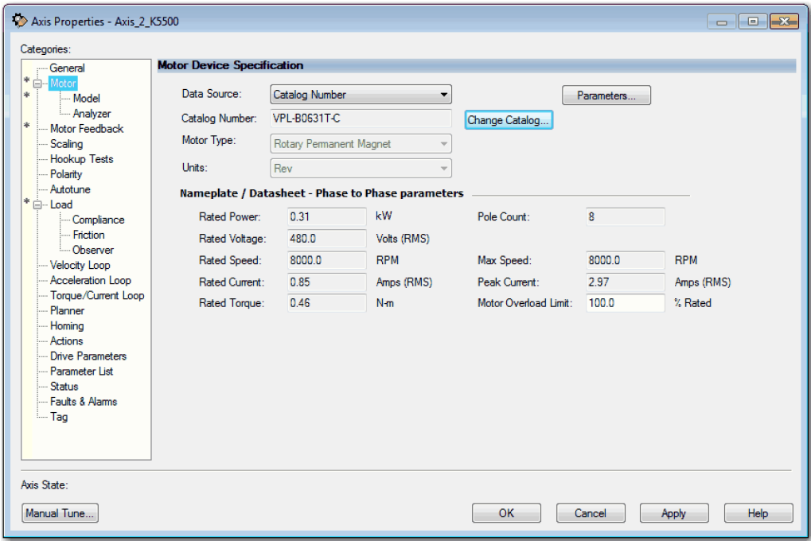

When you select the Catalog Number for the motor specification, the VPL-B0631T-C motor is in the Motion Database. The specification data for this motor is automatically completed for you.

If the motor you are using is not in the Change Catalog list, then it is not in the Motion Database. You must input the specification data or add a custom motor to the Motion Database that can be selected.
For more information, see Choose Nameplate as the Motor Data Source on page 51.

5. Click the Motor Feedback dialog box.

With this drive and motor combination, the Motor-Mounted Feedback that is available is the Hiperface DSL type. The data is automatically populated based on that selection. You can assign the commutation alignment.

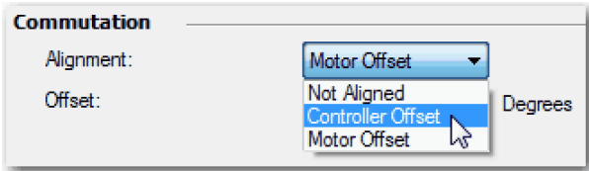

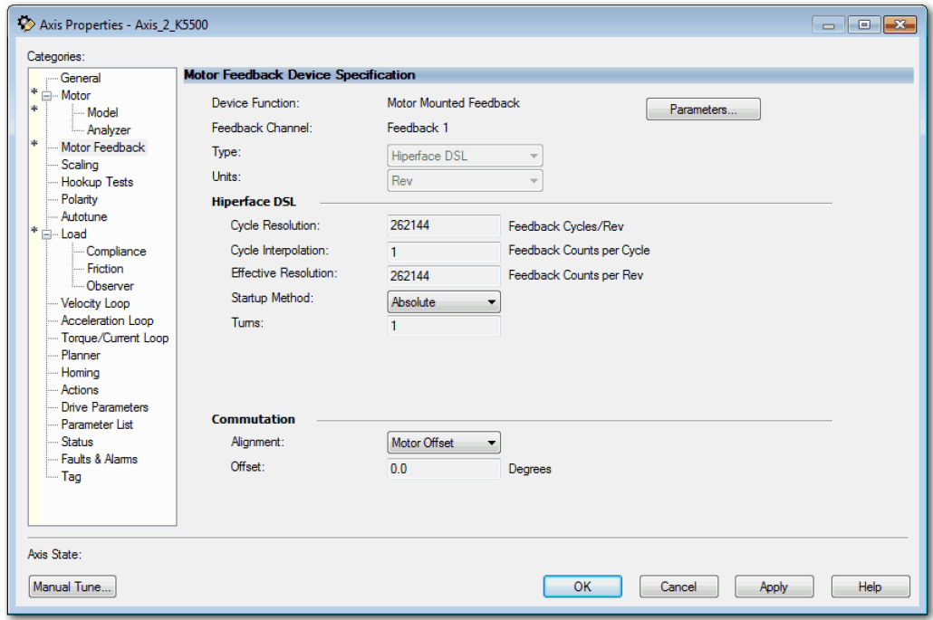

6. To adjust the Scaling attributes, click the Scaling dialog box.
7. Choose the Load Type.
8. Enter the Scaling Units.
9. Choose the Travel Mode.
For more information about Scaling, see Scaling on page 137.
10. Click Apply.

You are now finished configuring the Kinetix 5500 axis for Velocity Loop with Motor Feedback.

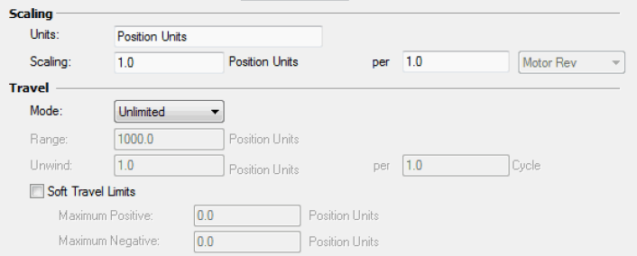
Commission an Axis

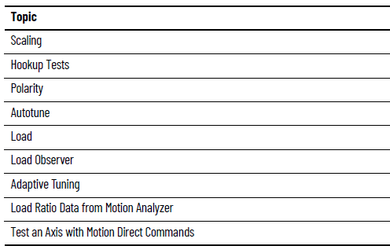

Commission the axis after you have followed the steps in these sections:

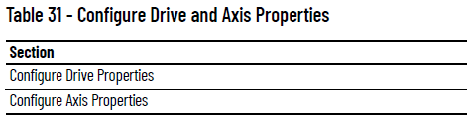

Axis motion can be specified in whatever units you want. In the Scaling dialog box, you configure the motion control system to convert between raw internal motion units. For example, Feedback Counts or Planner Counts can be converted to your preferred unit of measure, be it revolutions, degrees, meters, or inches.

This conversion involves three key Scaling Factor attributes:
- Conversion Constant,
- Motion Resolution, and
- Position Unwind.

If you use the Scaling dialog box, the software calculates the Scaling Factors for you. The only task that you do is select the Load Type that best matches the mechanical linkage between the motor and the load.

There are four Load types:
- Direct Coupled Rotary
  - The load is directly coupled to the linear motor moving mass.
- Direct Coupled Linear
  - The load is directly coupled to the linear motor moving mass.
- Rotary Transmission
  - The rotational load is coupled to the motor through a geared transmission.
- Linear Actuator
  - The linear load is coupled to a rotary motor through a rotary to linear mechanical system.

This figure shows the default Scaling dialog box for a Direct Coupled Rotary load type. By default, the Scaling dialog box is set for 1 ‘Position Unit’ per Motor Rev.

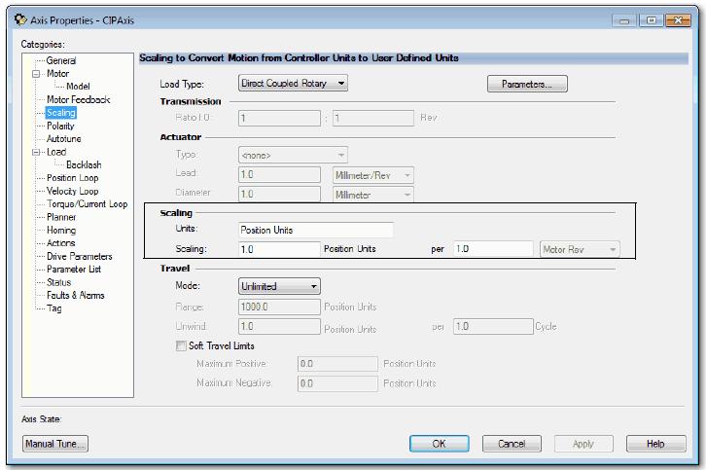

When you click Parameters, you see values for the Conversion Constant and the Motion Resolution, each having a value of 1 million. These values are generated from the software calculator.

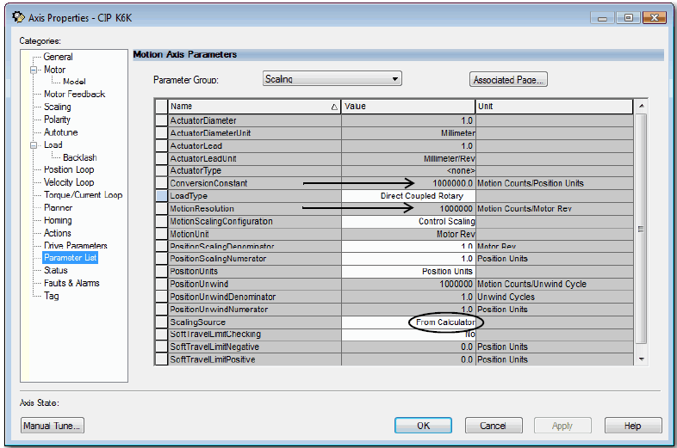

In most cases, the software scaling calculator generates Scaling Factor values that are suitable for the application. But in rare cases, like applications that require online product recipe changes, you can set the Scaling Source attribute to Direct Scaling Factor Entry. This attribute allows you to enter the Scaling Factors.

Direct Coupled Rotary

For a Direct Coupled Rotary load type, you can express Scaling Units for the rotary motor, for example, Degrees. Here is an example of Direct Coupled Rotary load that is scaled in Degrees and the resulting values for the Conversion Constant and Motion Resolution.

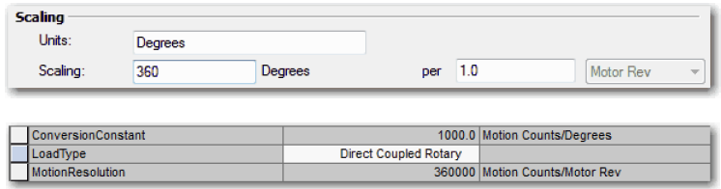

Direct Coupled Linear

For a Direct Coupled Linear load type, you can express Scaling Units for the linear motor, for example, Inches. Here is an example of Direct Coupled Linear load that is scaled in Inches and the resulting values for the Conversion Constant and Motion Resolution.

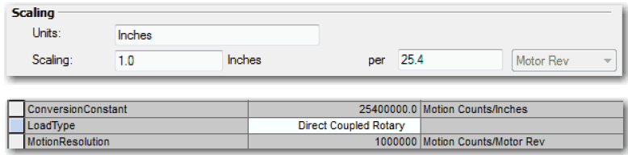

For more information about Conversion Constant and Motion Resolution, see the Integrated Motion on the EtherNet/IP Network Reference Manual, publication MOTION-RM003.

Rotary Transmission

For a Rotary Transmission load type, you enter the Transmission ratio mechanical system. When you allow the software scaling calculator to compute the Scaling Factors by using the Transmission Ratio, it reduces the risks of cumulative errors due to irrational numbers.

Here is an example of Rotary Transmission load that is scaled in Packages (three packages per Load Revolution) and the resulting values for the Conversion Constant and Motion Resolution.

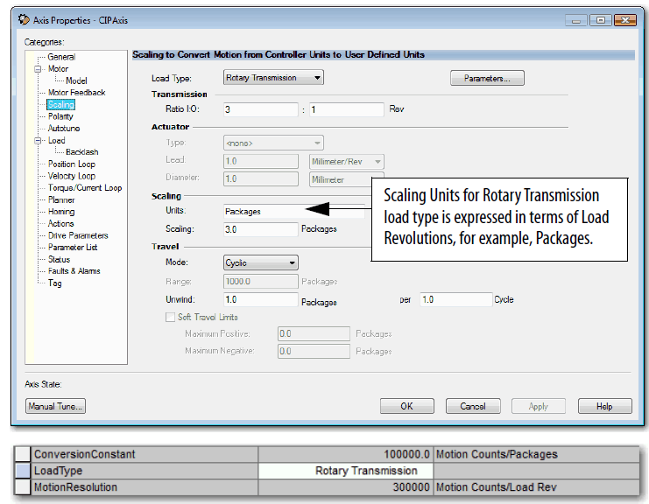
References:
https://www.motioncontroltips.com/what-are-rotary-actuators-and-how-do-they-differ-from-rotary-tables/
https://www.linearmotiontips.com/what-is-a-direct-drive-motor/
https://en.wikipedia.org/wiki/Electric_motor

Linear Actuator

With the Linear Actuator load type, you can specify the characteristics of the linear actuator mechanics by the Actuator Type.

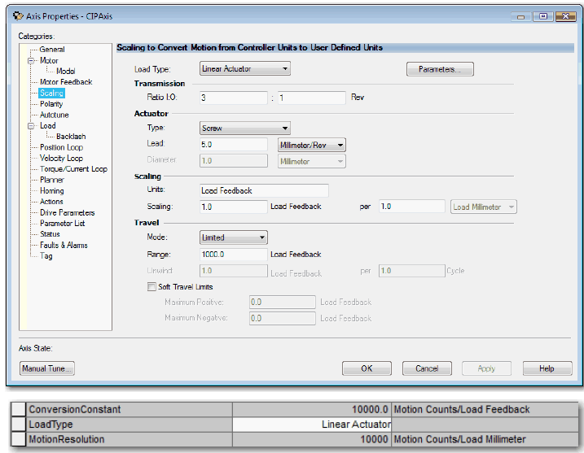

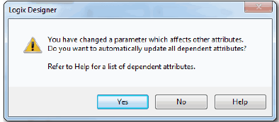
Changing Scaling Factors

Changing Scaling configuration factors can have a significant impact on the calculations of factory defaults for scaling dependent-axis configuration attributes. If you change a scaling factor that impacts other attributes, the following dialog box appears when you apply the change.
This dialog box gives you the choice to recalculate factory defaults for scaling dependent attributes.
- To recalculate and apply all dependent attribute values, click Yes.
- To apply only changes to the scaling attributes, click No.

Once you have applied your configurations, the factory defaults for dynamic configuration attributes, for example, gain, limits, and filter settings are automatically computed. The calculations are based on your drive and motor configuration settings and selection for application type and loop response.

The factory defaults yield a stable operational system that can then be tailored to the specific requirements for many types of machine applications.

You can use Autotune to improve performance if the gain set provided to you by the factory defaults does not satisfy the configuration requirements of your system. See Autotune on page 150.

Hookup Tests

Use the Hookup Tests dialog box to perform the following:
- Check your cabling
- Adjust motor and feedback polarity
- Establish your sense of positive motion direction
- If applicable, check encoder marker and commutation function

To run any of the Hookup Tests, you must first download your program.

ATTENTION: These tests can actively move the axis even with the controller in Remote Program mode:
- Before you do the tests, make sure no one is in the way of the axis.
- Changing motor or feedback after performing the Hookup Test can result in an axis-runaway condition when the drive is enabled.
- To avoid personal injury or damage to equipment, you must remove the load from each axis as uncontrolled motion can occur when an axis with an integral motor brake is released during the test.

The type of drive and the combination of the Axis and Feedback configuration types you choose determine what Hookup tests are available.

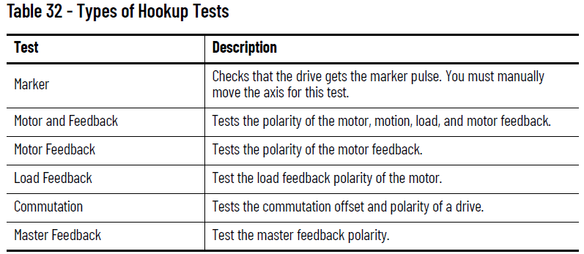
Table 33 lists the Hookup Tests that is based on axis configuration and drive type.
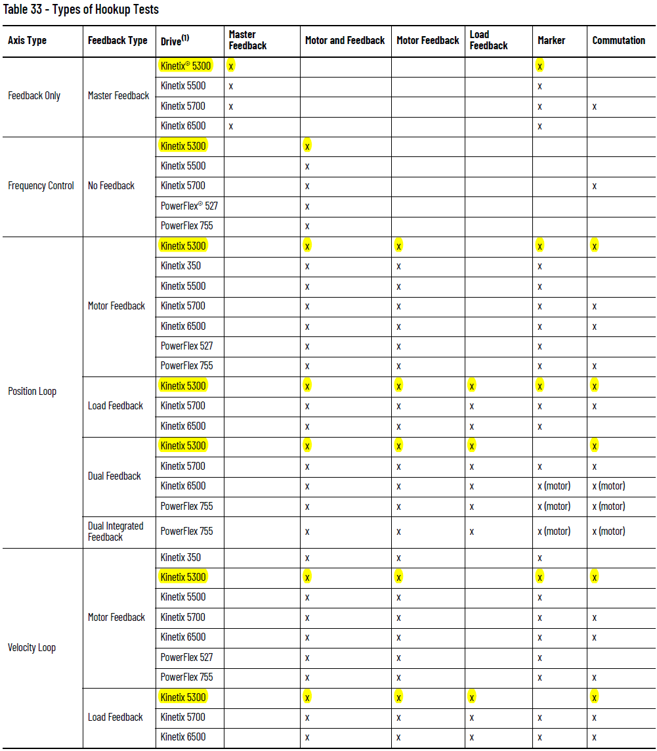
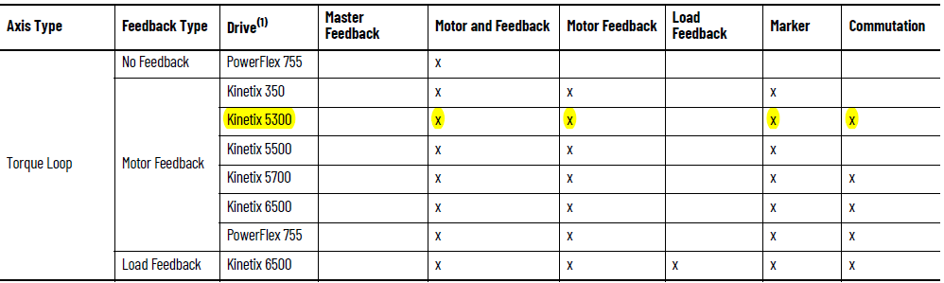

Run a Motor and Feedback Test

The Motor and Feedback Test is the most commonly used Hookup Test because it automatically tests both the motor and feedback wiring and determines correct polarity values.

ATTENTION: These tests make the axis move even with the controller in remote Program mode. Before you do the tests, make sure no one is in the way of the axis.

Follow these steps to perform a Motor and Feedback Hookup Test.
- Go to the Hookup Tests dialog box.

Remember that a blue arrow next to a field means that when you change its value the new value automatically gets written to the controller when you leave the field.

- Enter the Test Distance.

The Test Distance is the distance that the test moves the axis.

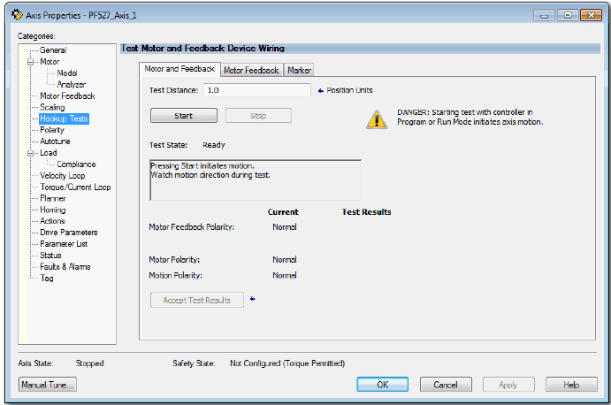
- To run the Motor and Feedback test, click Start.
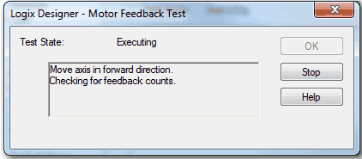

- The axis moves on its own to test for feedback polarity and proper wiring. To check for proper rotation direction, watch the axis.
The drive determines that the feedback device is working properly and the test passed.

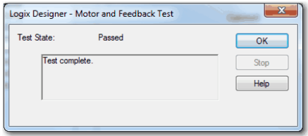

- Click OK.

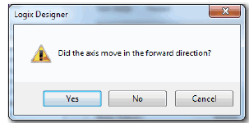

- If your axis moved in a forward direction, click yes and you see that the test result is Normal.

If the motor does not move in the forward direction, according to your application the test result is inverted. When you accept test results the Current shows inverted. See the Polarity on page 150.

If you are satisfied with the results, you can accept the test results.

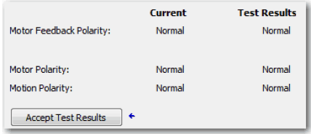

The test can pass but give you results that you are not expecting. In this case, you can have a wiring problem. See the related drive documentation that is listed in the Additional Resources on page 9.

7. Click Yes or No depending on whether the axis moved in the forward
direction for your application.

8. Click Accept Results, if the test ran successfully.
Run a Motor Feedback Test

The Motor Feedback Test checks the polarity of the motor feedback. Follow these steps to perform a Motor Feedback test.
1. From the Hookup Tests dialog box, click the Motor Feedback tab.

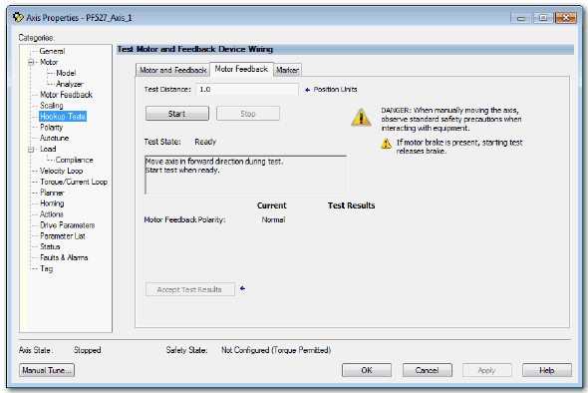

2. Enter the Test Distance.
3. Click Start.

Run a Marker Test

The Marker Test checks that the drive receives the marker pulse from the position feedback device. You must manually move the axis for this test. Follow these steps to perform a Marker test.

1. From the Hookup Tests dialog box.
2. Click the Marker tab.
3. To check for the marker pulse, click Start.

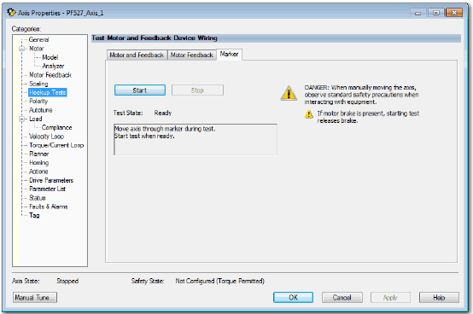
4. Manually move the axis until you get the marker pulse.

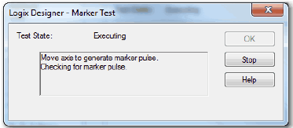

The drive receives the marker pulse and the test passed.

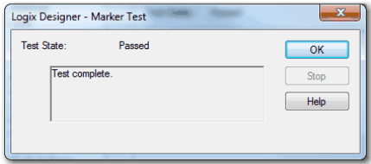

5. Click OK.

Applying the Commutation Hookup Test

The Commutation Test determines an unknown Commutation Offset and potentially the unknown polarity of the startup commutation wiring. The Commutation Test can be used also to verify both a known Commutation Offset and the polarity startup commutation wiring. This test is applied to third-party or custom Permanent Magnet motors that are not available as a Catalog Number in the Motion Database.

For linear stages, make sure that there is enough available travel, otherwise the commutation test produces a fault.

When a motor needs a Commutation Offset and you are not using Catalog number as the Motor Data Source, you cannot enable the axis.

Pg 147 in Rockwell Automation Publication MOTION-UM003L-EN-P - November 2020

Run a Commutation Test

Set the Motor and Feedback Polarity by using the Motor and Feedback Test before running the Commutation Test.

This setting helps make sure that the motor spins in the correct direction for the Commutation Test for monitoring the Commutation Angle.

Run the Motor and Feedback Test first to determine that your feedback is working. If the Feedback is not working, the Commutation Test gives you incorrect results or the test times out.

1. To run the Commutation Test to determine the Commutation Offset and Commutation Polarity, click Start.

The Kinetix 350, Kinetix 5500, and PowerFlex 527 drives do not support the Commutation Polarity attribute.

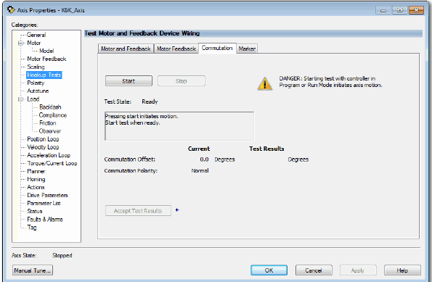

The drive executes the Commutation Test, which includes motor rotation in the positive direction by at least one revolution. The results of the Commutation Test appear.

2. If the results are satisfactory, click Accept Test Results.

Commutation Offset and Polarity results are stored in the controller as part of the axis configuration that is sent to the drive during initialization.

Polarity

If you have run the Motor and Feedback Hookup Test, the settings on the Polarity dialog box are already correct for the application. If the polarity settings are known and cables to the motor and feedback devices are prefabricated and tested, the polarity settings can be entered on this dialog box.

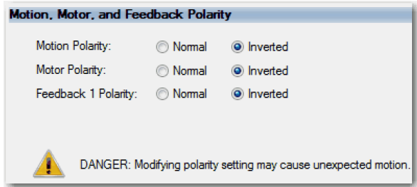

The axis is now ready for operation. You can use Direct Commands to initiate axis motion or you can run your application program. If you find that the dynamic performance of your axis does not meet your system requirements, use Autotune to improve performance.

Autotune

Once you have set the parameters and performed tasks in the General, Motor, Motor Feedback, Scaling, Hookup Test, and Polarity dialog boxes, you are ready to Autotune, if necessary.

Typically, you do not need to use Autotune or Manual Tune. Once you select your drive and use the Motion Database as the data source, the defaults can provide adequate tuning performance. If the default values do not provide adequate performance for the application, it is recommended that the drive be configured for tuning-less operation. For information on how to configure a drive for tuning-less operation, see the Tuning-less Feature Configuration
Quick Start Guide, publication MOTION-QS001.

If the tuning-less features are not available for your drive, use autotune to adjust the parameters. For detailed tuning information, see the Motion System Tuning Application Technique, publication MOTION-AT005.

ATTENTION: When you tune an axis, it moves even with the controller in Remote Program mode. In that mode, your code is not in control of the axis. Before you tune an axis, make sure no one is in the way of the axis.

If the drive has not been enabled before (new installation), verify that you have safeguards in place to safely remove power from the drive if there is an unstable situation where the drive can produce undesired motion.

To use the Autotune feature, use the following steps.

1. Click the Autotune dialog box.

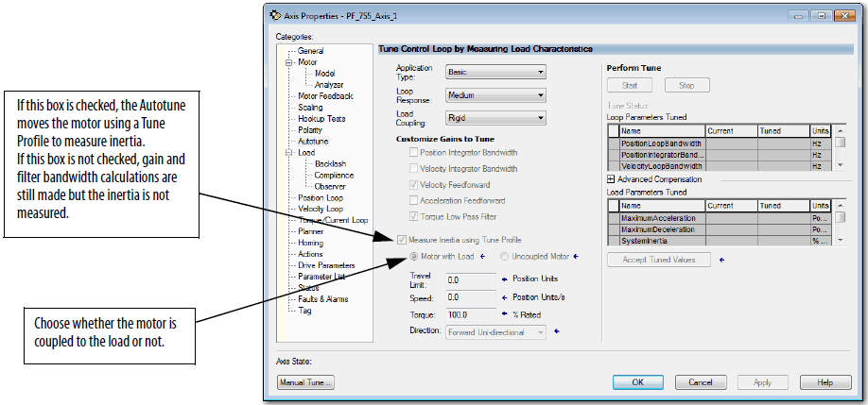

To configure the Tune Profile, you enter the Travel Limit, Speed, Torque, and Direction.

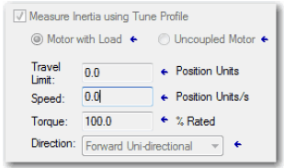

- Set the Travel Limit that is based on the travel constraints of the machine.

- Set the Speed to the expected operation speed.

- Set the Torque to the level you want to apply to the motor during the Autotune. The default of 100% Rated Torque usually give good results.

- Set the Direction that is based on machine constrains.

Unidirectional tune profile measures inertia and friction. Bidirectional tune profile adds measurement of active torque loading.
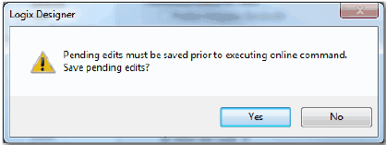
- Click Start.

This message appears if you have edits that have not been applied. If you do not save edits that are pending, Autotune does not run.
The Autotune status displays Success. A tune configuration fault can occur if any number of attributes are zero.

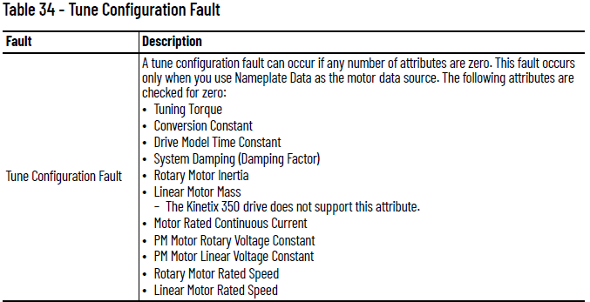

The Autotune profile accelerates and decelerates the motor according to the Tune Direction.
Once the Autotune is finished, the test state changes.

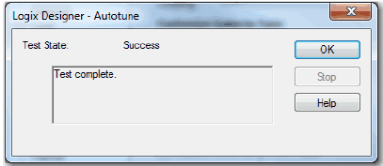

7. Click OK.

After completing the Autotune profile, the measurements that are made during this process are used to update the fields in the Gains Tuned and Inertia Tuned grids.
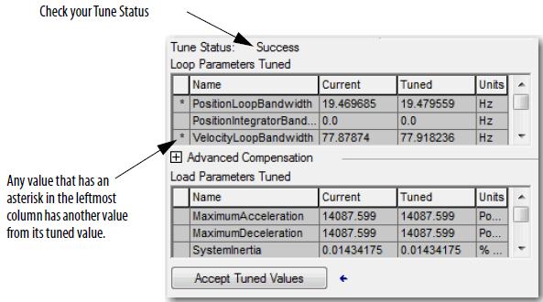
8. You can compare existing and tuned values for your gains and inertias with the prospective tune values.

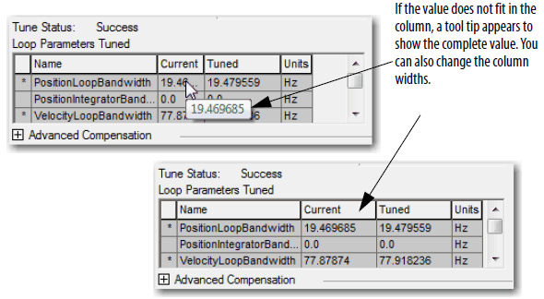
9. Choose to accept the new values and apply them to the controller.

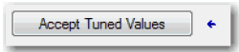

Now you can run the system with the new gain set and evaluate performance. You can improve the performance by adjusting application type, loop response, and/or load coupling selections.

If your application requires stricter performance, you can further improve performance with manual tuning. See When to Manually Tune an Axis on page 191.

LOAD

The Load dialog box contains the characteristics of the motor load.

- If you use the Catalog Number as the Data Source, the Motor Inertia, Total Inertia, and System Inertia are pre-populated with the correct values.
- If you know what the Load Ratio values are, you can enter that information on the Load dialog box or you can use the values that are provided by Autotune.

IMPORTANT If utilizing the tuning-less features, it is recommended to set the Load Ratio to zero. For information on how to configure a drive for tuning less operation, see the Tuningless Feature Configuration Quick Start Guide, publication MOTION-QS001.

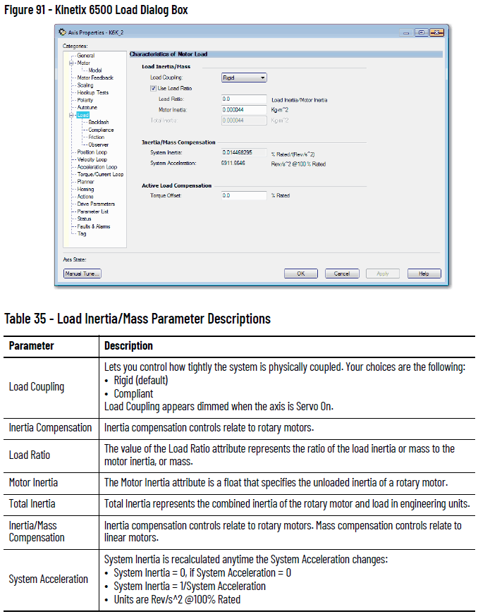

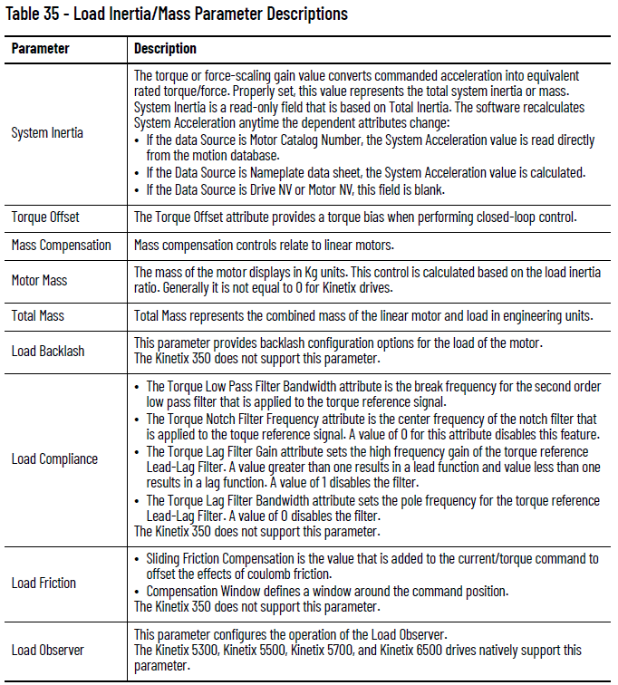

See the Integrated Motion on the EtherNet/IP Network Reference Manual, publication MOTION-RM003, for detailed descriptions of the AXIS_CIP_DRIVE attributes.

Load Observer

The Load Observer feature is a control loop inside the drive that estimates the mechanical load on the motor and compensates for it. This feature lets the control loops to treat the motor as if it is unloaded and relatively easy to control. The Load Observer automatically compensates for disturbances and load dynamics, such as sudden inertia changes, compliance, backlash, and resonances that are within the bandwidth of the Load Observer.

For detailed tuning information, see the Motion System Tuning Application Technique, publication MOTION-AT005.

Benefits of Load Observer

The Load Observer Feature provides the following benefits:

- Provides relatively high-performance motion control without tuning
- Minimizes the need to retune to account for machine wear over time
- Automatically compensates for changes in vibration and resonance that are within the bandwidth of the Load Observer
- Mitigates periodic identification of in-band resonance to compensate for them

How Load Observer Functions

The Load Observer acts on the acceleration signal within the control loops and monitors the Acceleration Reference and the Actual Position feedback. The Load Observer models an ideal unloaded motor and generates a load Torque Estimate that represents any deviation in response of the actual motor and mechanics from the ideal model. This deviation represents the reaction torque that is placed on the motor shaft by the load mechanics. Closed-loop operation compensates the deviation, which is estimated in real time. See Figure 92 on page 157 for an example Load Observer block diagram.

The Load Observer also generates a Velocity Estimate signal that you can apply to the velocity loop. The Velocity Estimate has less delay than the Velocity Feedback signal derived from the actual feedback device. It also helps to reduce high frequency output noise that the aggressive action of the Load Observer on the acceleration reference causes. Together, Load Observer with Velocity Estimate provides the best overall performance for positioning applications. Table 36 describes the Load Observer configuration settings.

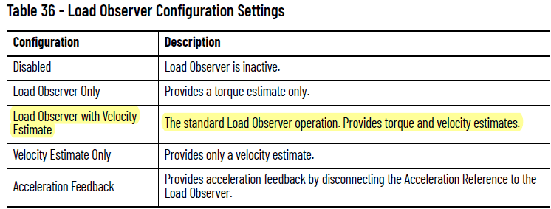
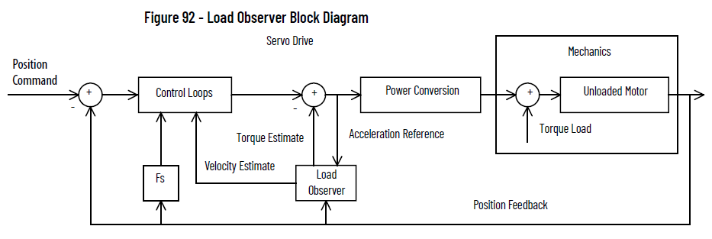

Load Observer Configuration

Click the Observer tab in the Axis Properties dialog box. Here, the Load Observer mode can be selected with the Configuration pull-down menu. See Table 27 for descriptions of each setting. If Load Observer is enabled, the recommended Configuration setting is Load Observer with Velocity Estimate for positioning applications. Access to
Load Observer bandwidth (Kop) and Load Observer Integral Bandwidth (Koi) is also shown. Typically, Koi = 0.

Gains are limited to 500 Hz in drive firmware revision 2.160 and earlier. In drive firmware revision 2.170 and later, the gain limits are increased to 10,430 Hz.

The Load Observer can be configured in various ways by using the Load Observer Configuration attribute. The standard configuration is Load Observer with Velocity Estimate. This configuration approximates the load torque and minimizes the phase lag associated with the velocity feedback.

For more information, see the Motion System Tuning Application Technique, publication MOTION-AT005.

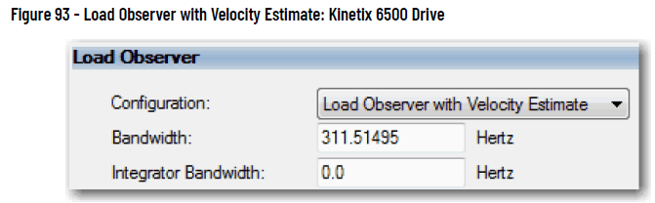

Adaptive Tuning

The Adaptive Tuning feature is an algorithm inside of the drive. This feature continuously adjusts or adapts various filter parameters and control loop gains to compensate for unknown and changing load conditions while the drive is running. Its primary functions are as follows:

- Automatically adjust torque loop notch and low pass filter parameters to suppress resonances
- Automatically de-tune control loop gains to avoid instability when it is detected

For detailed tuning information, see the Motion System Tuning Application Technique, publication MOTION-AT005.

Benefits of Adaptive Tuning

Adaptive Tuning performs the following:
- Automatically suppresses changing resonances
- Minimizes periodic identification of resonance and retuning
- Mitigates the need for a tuning expert
- Reduces decommissioning time, especially for high axis count
- Minimizes the power consumption, machine vibration, and errors

How Adaptive Tuning Functions

Adaptive Tuning is always running in the background to detect motor side resonances. Adaptive Tuning periodically analyzes the frequency response of torque loop signals to identify, track, and measure resonances. Adaptive Tuning also analyzes the frequency response of the command signal to make sure that dominant command frequencies are not mistaken for resonances. This process is known as command rejection. The action that is taken to change tuning parameters largely depends on the adaptive tuning mode of operation.

The configurable Adaptive Tuning parameters from the Compliance Category of the Axis Properties are listed in the following table. For a list of all of the Adaptive Tuning attributes, see the Motion System Tuning Application
Technique, publication MOTION-AT005.

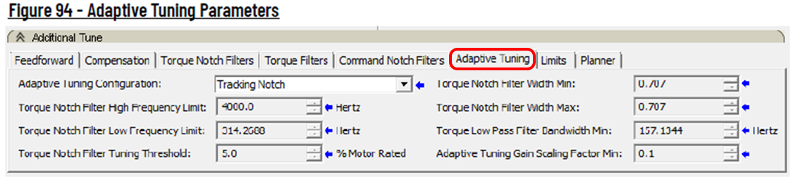

For the purposes of this manual, resonances are characterized as follows:
- HF resonances are above the low frequency limit
- LF resonances are below the low frequency limit
- MF resonances are slightly above the low frequency limit
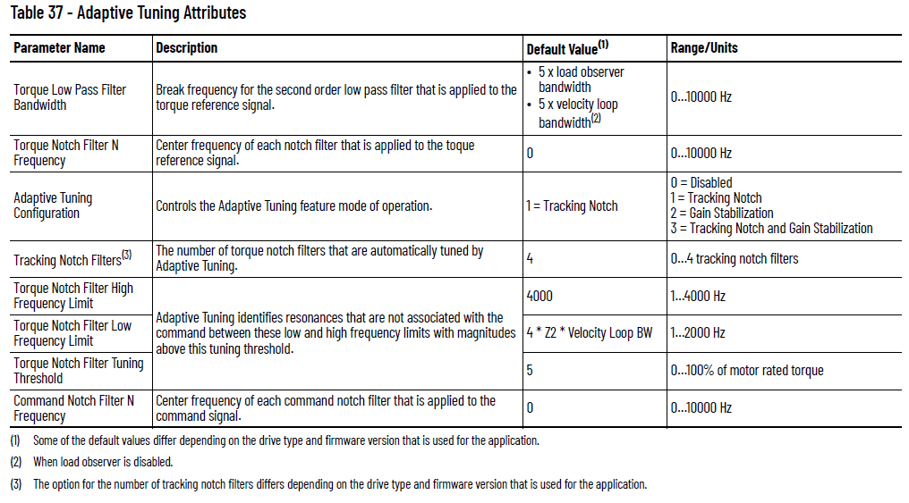

Adaptive Tuning Configuration

The modes of adaptive tuning operation include:
• Disabled
• Tracking Notch
• Gain Stabilization
• Tracking Notch and Gain Stabilization

You access adaptive tuning from the Compliance tab on the Load Category page.

Disabled

Adaptive Tuning is always running in the background to identify motor side resonances, even when the feature is disabled.

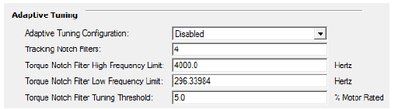

No action is taken to compensate for the identified resonances in this mode. The result is status only, which lets you create custom Ladder Logic to react to changes. This function is useful for condition monitoring, diagnostics, and preventative maintenance purposes in tracking HF resonances that change over time. The Adaptive Tuning output parameters can be selected and monitored in the Drive Parameters tab of the Axis Properties dialog box.

Tracking Notch

Typically the Torque Notch Filter Frequencies on the Compliance tab of the Axis Properties dialog box are applied to the torque notch filters. In this mode, the Torque Notch Filter Frequency Estimates that are identified by the drive are applied to the torque notch filters instead.

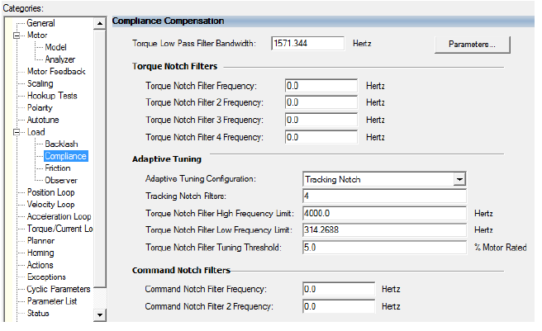

Gain Stabilization

Adaptive Tuning performs two primary functions in modes with Gain Stabilization.

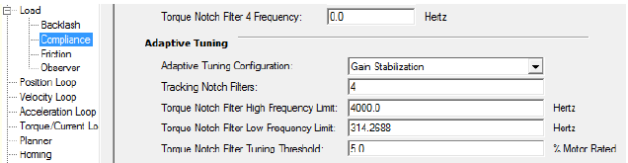

- Adaptive Tuning enables and tunes the low pass filter to suppress resonances if any are identified above the low frequency limit. Typically the Torque Low Pass Filter Bandwidth that is visible on the Compliance tab of the Axis properties dialog box is applied to the low pass torque filter.
- With Adaptive Tuning, the Torque Low Pass Filter Bandwidth Estimate that is identified by the drive is applied to the torque low pass filter instead. The bandwidth estimate is incrementally decreased from its default value until the identified HF resonances are suppressed or an LF resonance or instability occurs.

Tracking Notch and Gain Stabilization

When Tracking Notch and Gain Stabilization are enabled, the drive applies the Tracking Notches if necessary, followed by Gain Stabilization, if necessary. Notch Filter Tuning sets the torque notch filters to suppress High Frequency resonances that may exist. Gain Stabilization applies the low pass filter to suppress additional HF resonances if they exist. This function is useful for suppressing more HF resonances than there are notch filters. If the system is unstable, Gain Stabilization incrementally detunes control loops until the system is stable.

The system is detuned if one or more of the following conditions exist:
- A torque notch filter was set to suppress a MF resonance. The width of the torque notch filter is wide enough or its frequency is close enough to the closed-loop bandwidth to cause instability
- The torque low pass filter was set to suppress a MF resonance, but its bandwidth is close enough to the closed-loop bandwidth to cause instability
- Any additional unsuppressed resonances are present.
For detailed descriptions of the Adaptive Tuning Status Bits, see the Motion System Tuning Application Technique, publication MOTION-AT005.

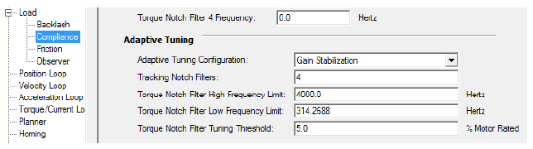

Adaptive Tuning enables and tunes the low pass filter to suppress resonances if any are identified above the low frequency limit. Typically the Torque Low Pass Filter Bandwidth that is visible on the Compliance tab of the Axis properties dialog box is applied to the low pass torque filter. With Adaptive Tuning, the Torque Low Pass Filter Bandwidth Estimate that is identified by the drive is applied to the torque low pass filter instead. The bandwidth estimate is incrementally decreased from its default value until the identified HF resonances are suppressed or an LF resonance or instability occurs.

The gain stabilization function detunes control loop gains to suppress any remaining resonances and stabilize the system. The Adaptive Tuning Gain

Scaling factor scales the following gains:

- Load Observer Bandwidth
- Load Observer Integrator Bandwidth
- Velocity Loop Bandwidth
- Velocity Loop Integrator Bandwidth
- Position Loop Bandwidth
- Position Loop Integrator Bandwidth

The actual control loop gains are the values that are shown in the Axis Properties dialog box multiplied by the gain scaling factor. The scaling factor is incrementally decreased from its default value until the system is stable. When Gain Stabilization is not enabled, the scaling factor is reset to its default value of 1 so that control loop gains are not affected.

Gain Stabilization is good for situations where there are more resonances than there are notch filters and for keeping the axis stable.

Instability and audible noise is caused from the following situations:

- HF resonances that filters do not already suppress
- MF resonances that filters suppress where the filter bandwidths are too close to the closed-loop bandwidth
- LF resonances that result when Load Observer is not applied with the recommended out-of-box settings
- LF resonances that result from classical instability

IMPORTANT We do not recommend that you enable Gain Stabilization on vertical loads as detuning can cause load drops.

Command Notch Filters

Even when all motor side resonances are suppressed and the motor shaft is tightly controlled using closed loop feedback, the load end effector can still oscillate at a few Hertz through a compliant mechanical connection or linkage to the motor. These oscillations are load side resonances that are unobservable in the feedback signal and are not measurable by the feedback device on the motor.

Benefits of Command Notch Filters

The Command Notch Filters can be used to minimize load side resonances that result in end effector vibration that is common in robots, cranes, cantilevered loads, anti-sway, liquid sloshing, laser cutting, and material handling applications.

Command Notch Filter Configuration

To apply a Command Notch filter, first specify a smooth reference move profile. Then determine the load oscillation frequency with either an empirical formula, a stopwatch, or a high speed camera and then apply a command notch filter at that frequency.

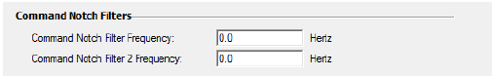

For more details about the Command Notch filters, see the Motion System Tuning Application Technique, publication MOTION-AT005.

Load Ratio can also be found through Autotune from Motion Analyzer. If you do not want to run the Autotune, you can manually enter the load ratio from other sources such as Motion Analyzer. See Help for Selecting Drives and Motors on page 14 for more information about the Motion Analyzer.

Test an Axis with Motion Direct Commands

Motion direct commands let you issue motion commands while you are online without having to write or execute an application program. You must be online to execute a Motion Direct Command. There are several ways to access the Motion Direct Command.

Motion Direct Commands (MDC) are useful when you are commissioning or troubleshooting a motion application. During commissioning, you can configure an axis and monitor the behavior by using Trends in the Controller Organizer. Use of Motion Direct Commands can fine-tune the system with or without load to optimize its performance. When testing and/or troubleshooting, you can issue Motion Direct Commands to establish or reestablish conditions such as Home. Often during initial development, test the system in small manageable areas. These tasks include the following:

- Home to establish initial conditions
- Incrementally Move to a physical position
- Monitor system dynamics under specific conditions

To access the Motion Direct Commands for the Motion Group or axis, right click the Group or Axis in the Controller Organizer and choose Motion Direct Commands.

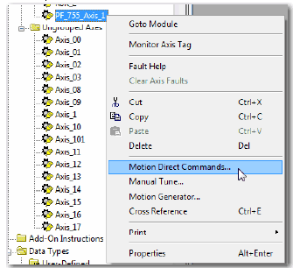

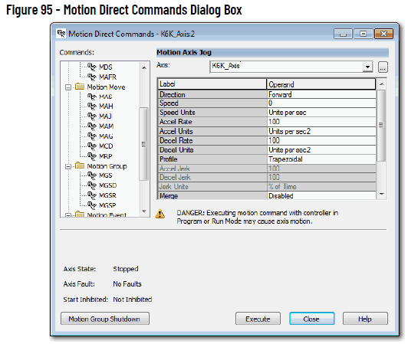
The content of the Motion Direct Command dialog box varies, depending on the command you have chosen. In the Command list, you can either type the mnemonic and the list advances to the closest match or you can choose a command from the Axis pull-down menu. Choose the desired command and its dialog box appears. You can access an axis by using the pull-down list. Axis status indicators are in this dialog box.

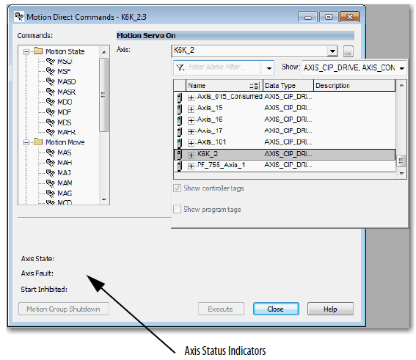

This dialog box is an example of axis indicator values.

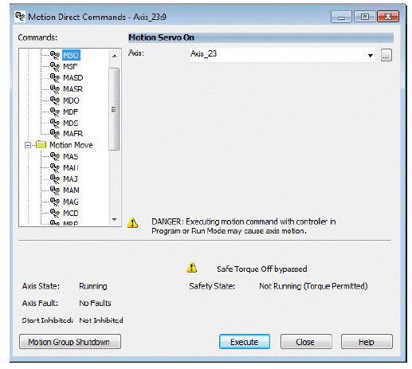

IMPORTANT The device spins at the command velocity once you execute an MDS command if you use a PowerFlex 755 drive in Velocity Mode with Flying Start Enable set to true.
For more information about the Flying Start Attribute, see the Integrated Motion on the EtherNet/IP Network Reference Manual, publication MOTION-RM003.
For complete information about Motion Direct Commands in motion control systems including the Safe Torque Off feature, see the publications that are listed in the Additional Resources on page 9.

=============================================================================

Homing

Homing puts your equipment at a specific starting point for operation. This starting point is called the home position.

When using integrated motion on the EtherNet/IP network, all active and passive homes are setting absolute positions as long as an absolute device is being used.

See the Integrated Motion on the EtherNet/IP network Reference Manual, publication MOTION-RM003, for more details about the Homing attributes.

To configure the homing procedure, you specify the mode (active or passive) and sequence. Based on those selections, you can also choose the home position, an offset for the home position, the direction, and speed. For switch-based sequences, you can also select whether the limit switch is normally open or normally closed.

Guidelines for the Homing Procedures

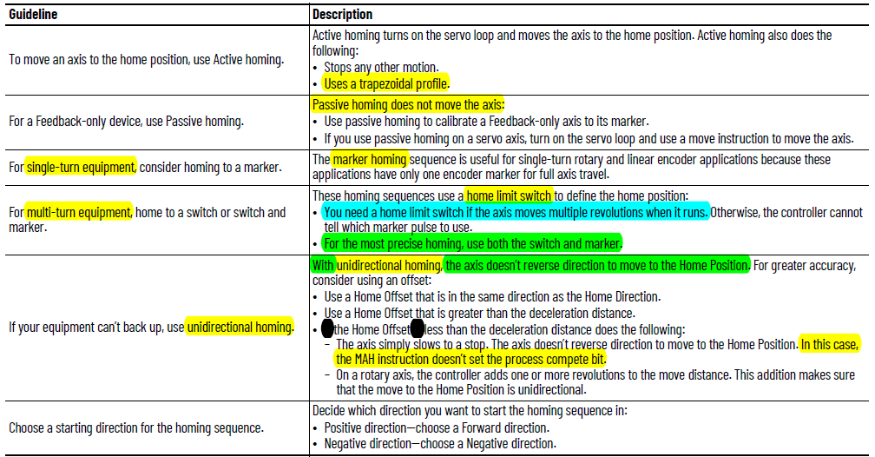

Active Homing

- When the axis Homing mode is configured as Active, the physical axis is first activated for servo operation.
- As part of this process, all other motion in process is canceled and appropriate status bits cleared.
- The axis is then homed by using the configured Home Sequence, which can be Immediate, Switch, Marker, or Switch-Marker.
- The latter three Home Sequences result in the axis being jogged in the configured Home direction.
- After the homing sequence is complete, the position is redefined.
- Based on detection of the home event, the axis is automatically moved to the configured Home Position.

IMPORTANT The control moves the axis to the unwind position of zero. This movement occurs only when unidirectional active homing is performed on a rotary axis and the Home Offset value is less than the deceleration distance when the home event is detected. This process helps make sure that the resulting move to the Home Position is unidirectional.

Passive Homing

- When the axis Homing mode is configured as Passive, the MAH instruction redefines the actual position of a physical axis on the next occurrence of the encoder marker or home sensor.
- The sequence determines the homing steps.
- You must set the homing sequence to marker or switch.
- Passive homing is most commonly used to calibrate Feedback Only axes to their markers or switch.
- Passive homing is identical to active homing to an encoder marker or switch except that the motion controller does not command any axis motion.
- After initiating passive homing (MAH), the axis must be moved past the encoder marker or trip the home switch for the homing sequence to complete properly.

For closed-loop Servo axes, when configured for Passive Homing, only set the Sequence to Immediate. Then when the MAH is executed, it simply sets the actual position to that of the Position value set in the Homing parameters. There is no physical motion with these settings.

Refer to the manual (the PDF this text came from) for homing examples beginning on page 176.

Absolute Position Recovery (APR)

APR is the recovery of the absolute position of an axis that has been machine referenced after a power cycle or reconnection.

- The APR feature maintains the machine reference or absolute position through power cycles, program downloads, and even firmware updates under certain conditions.
- The terms Absolute Position and Machine Reference Position are synonymous.

Absolute position is established by a homing procedure that is initiated by successful execution of an MAH instruction. Once the homing procedure has successfully established a machine reference, the Axis Homed bit is set in the Motion Status attribute, indicating that actual position and command position now have meaning regarding the associated machine.

If the Axis Homed status bit is clear, the APR function is bypassed and there is no attempt to restore absolute position. The clear status bit indicates that position has not been absolutely referenced to the machine.

SERCOS Versus Integrated Motion on Ethernet Networks

For a SERCOS axis with absolute feedback, the drive scaling function and absolute position are maintained in the drive. Therefore, the drive scaling function and absolute position can be easily restored in the control after a power cycle or download of a new project. This restoration is accomplished by reading the position from the drive.

By contrast, an integrated motion on the EtherNet/IP network axis supports controller-based scaling where absolute position is maintained in the firmware of the controller. Without the work of the APR feature, absolute position would be lost after a power cycle or project download.

APR Scenarios

ATTENTION: Whenever memory becomes corrupt, you lose position even if you have it stored on a memory card.

Table 43 on page 182 provides detailed information on when the APR feature recovers absolute position. The following assumptions must be considered. In each of these cases, the APR feature restores absolute position and preserves the state of the Axis Homed bit. This feature indicates that the axis has a machine referenced absolute position. Table 43 describes the scenarios whether the APR feature recovers absolute position.

APR Faults

An APR fault is generated when the system fails to recover the absolute position of the axis after power cycle, reset, or reconnection. When an APR fault occurs, the actual position of the axis is no longer correlated to the position of the axis prior to the power cycle, reset, or reconnect. APR Faults can be generated during initial axis configuration or during operation. APR faults are recoverable and can be cleared with a Fault Reset request. See Resetting an APR Fault on page 190.

The axis must be in the homed state, with the Axis Homed bit set, for an APR Fault to occur.

(fault list begins on page 185 of manual)

When to Manually Tune an Axis

If you are not sure if you should manually tune, use this process:
- If the software calculation defaults are acceptable, tuning is complete.
- If the software calculation defaults are not acceptable, and tuning-less features are available for your drive, configure the drive for tuning-less, otherwise, perform an Autotune. If the results are acceptable, tuning is complete.
See the Tuning-less Feature Configuration Quick Start Guide, publication MOTION-QS001.
See Autotune on page 150 for details.
- If the results are not acceptable, manually tune the axis.

Tune The Axis

The procedure for manual tuning begins on page 194.

The following instructions are available on the Motion Generator dialog box.

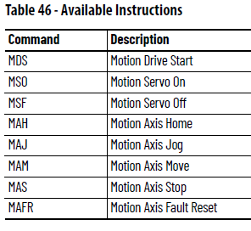

Instructions for using Motion Direct Commands begin on page 196.

Compensation Parameters

The Compensation tab lets you input scaling gain and friction offset values.

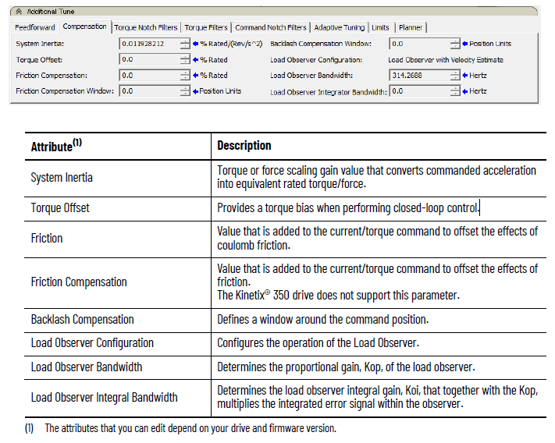
Torque Notch Filters Parameters

The Torque Notch Filters tab lets you adjust configuration values for the torque notch filters.

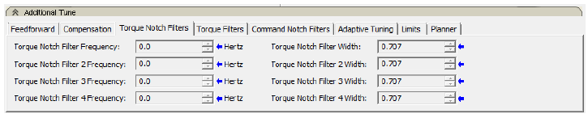

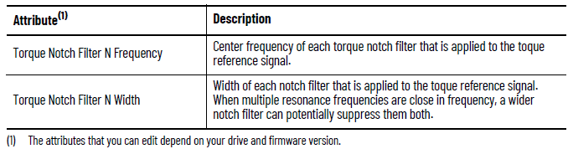

Torque Filters Parameters

The Torque Filters tab lets you input torque low pass and lag filter values.

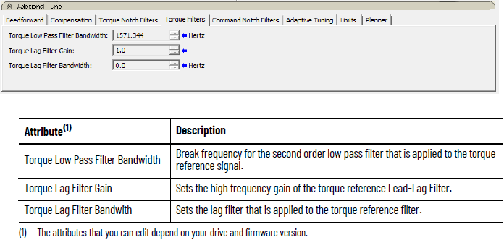

Command Notch Filters Parameters

The Command Notch Filters tab lets you adjust configuration values for the torque notch filters.

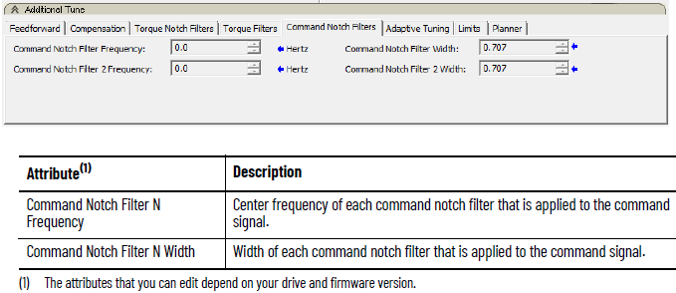

Adaptive Tuning Parameters

The Adaptive Tuning tab lets you adjust Adaptive Thing configuration values.

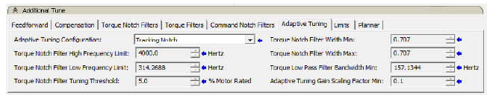

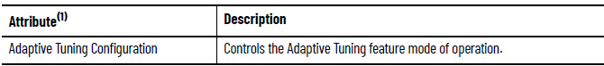
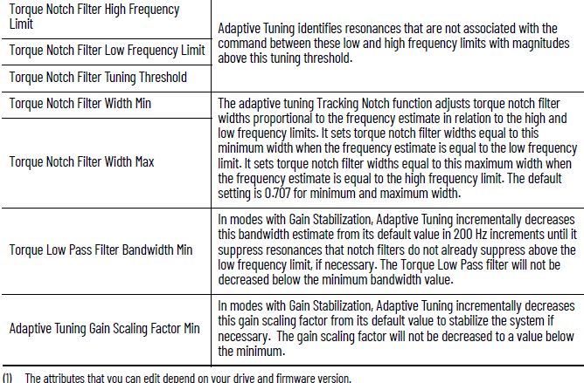

Monitor Tags with the Quick Watch Window

The Quick Watch window lets you monitor the tags in your program while you are executing commands. To open Quick Watch, press ALT+3 or choose it from the View menu.

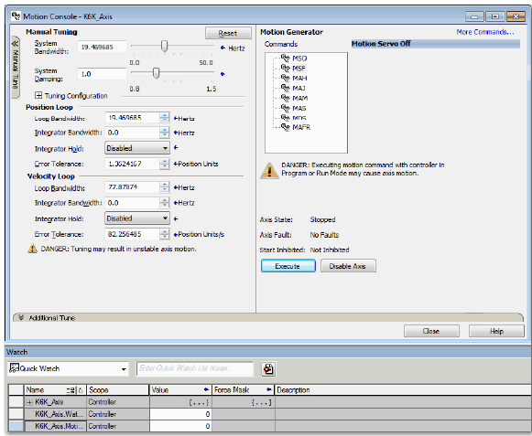

Use Motion Generator

This example assumes the following:
- The servo is off, with session Online
- Axis State: Stopped
- Axis Faults: No Faults
1. Choose MSO (Motion Servo On). This selection readies the drive for motion, and enables the servo loop.
2. Click Execute.

The axis state goes to Servo = On.

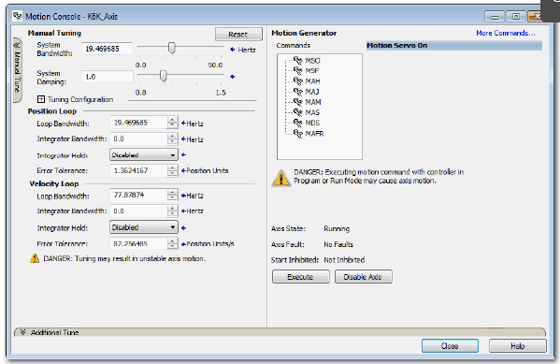
The Motion Console dialog box displays the following:
- Axis State: Running
- Axis Faults: No Faults
The Results window displays the following message.

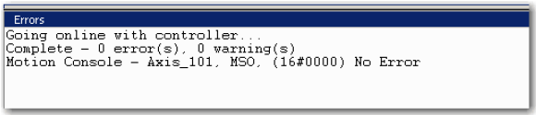
3. Select MAH (Motion Axis Home) and click Execute.
Use this step to execute the Homing command to establish a feedback positional reference, if a Position loop is being tuned.

The axis state goes Servo-On, and the controller performs the Axis Home procedure, which is based on the configured Home settings.

The Motion Console dialog box appears:
- Axis State: Running
- Axis Faults: No Faults
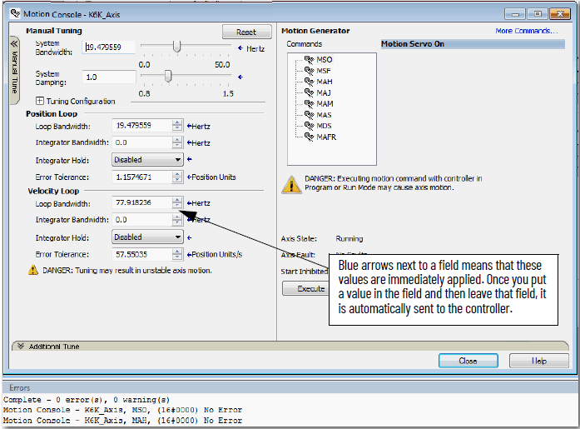

The Results window displays No Error.
4. Choose MAM (Motion Axis Move).
This step initiates an Axis-Move at the selected speed, acceleration/deceleration, profile, and endpoint position and lets you observe the axis response.

Before executing this MAM Move, you can initiate a method to observe the axis response during the move.
Some examples include the following:
- Watch-window:
Quick Watch tag name = Axis_y.ActualPosition or =
Axis_y.ActualVelocity
- New Trend with Tags:
Axis_y.ActualPosition or = Axis_y.ActualVelocity
- Axis Properties:
Status dialog box = Axis_y.ActualPosition or = Axis_y.ActualVelocity

5. Click Execute.

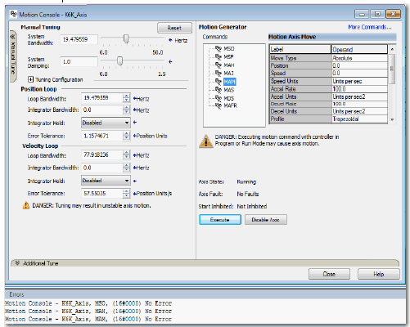

The controller performs a controlled axis move.
The Motion Console dialog box appears:
- Axis State: Running
- Axis Faults: No Faults
The Results window displays No Error.
6. Observe and verify the Axis response.
The axis motion moves according to the configured MAM settings:
- If the settings and response are satisfactory, then tuning is finished
- and you can close Manual Tune.
- If the settings or responses are not satisfactory, stay in Manual Tune
- and adjust the parameters.

==================================================================

Status, Faults, and Alarms

There are four ways to find and view faults and alarms:
- Fault and Alarm Log
- QuickView® Pane
- Tag Monitor, see the individual fault-related attributes
- Drive Status Indicators

Faults and Alarms Dialog Box

The Faults and Alarms dialog box displays the status of faults and alarms in the controller for an axis. The display is read-only except for the ability to clear logs. Fault and alarm entries are displayed only when you are online with a controller.
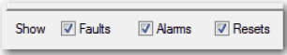
When online, check or clear the checkboxes in the Show row to show or hide the specified group of entries. Only the last 25 faults and alarms display.

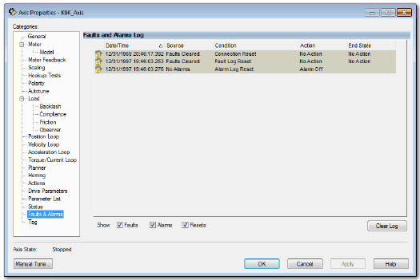
Figure 2 Figure 96 - Faults and Alarms Log

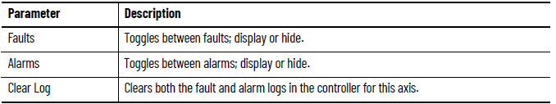

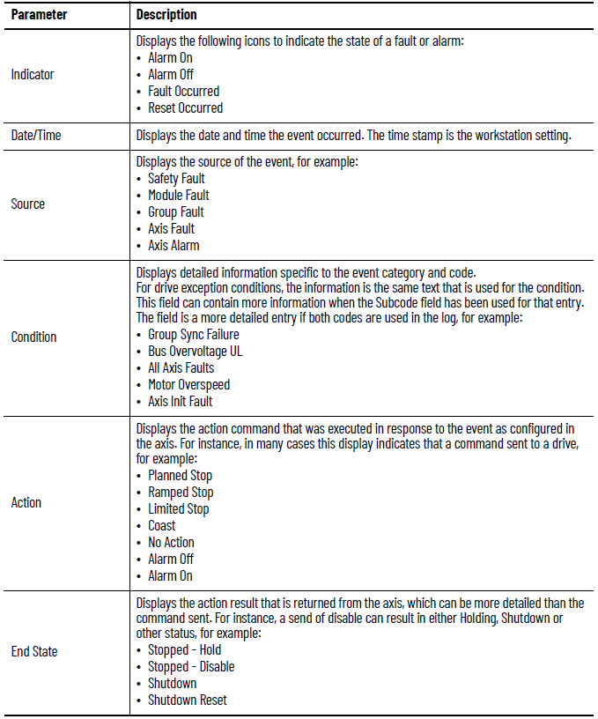

Motion Status

Pg 210
, motion-um003_-en-p.pdf
Integrated Motion on the EtherNetIP Network, Configuration and Startup

Remainder includes code examples

Resume at, Torque Notch Filters, pg
Integrated Motion on the EtherNetIP Network, Configuration and Startup, motion-um003_-en-p.pdf
November 2020
Remainder includes code examples

